Science FLE Y3/4 Animals including Humans
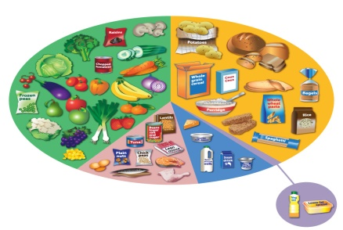
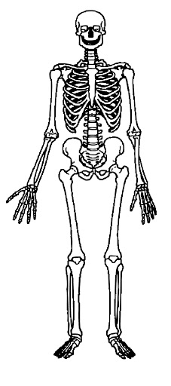
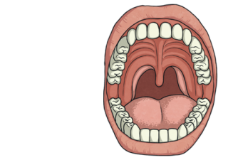

Forever Facts  Living things need food to grow and to be strong and healthy.  Plants can make their own food, but animals cannot.  To stay healthy, humans need to exercise, eat a healthy diet and be hygienic.  Animals, including humans, need food, water and air to stay alive.  Skeletons do three important jobs: protect organs inside the body; allow movement; support the body and stop it from falling on the floor.  Skeletal muscles work in pairs to move the bones they are attached to by taking turns to contract (get shorter) and relax (get longer).  Skills  I can ask relevant questions and using different types of scientific enquiries to answer them.  I can set up simple practical enquiries, comparative and fair tests.  I can make systematic and careful observations and, where appropriate, taking accurate measurements.  I can gather, record, classify and present data in a variety of ways to help in answering questions.  I can record findings using simple scientific language, drawings, labelled diagrams, keys, bar charts, and tables.  To coach Teignford Hockey team to success, presenting them with all the advice they need on diet, exercise and how to prevent injury.  I can report on findings from enquiries, including oral and written explanations, displays or presentations of results and conclusions.  I can use results to draw simple conclusions, make predictions for new values, suggest improvements and raise further questions.  I can identify differences, similarities or changes related to simple scientific ideas and processes.  I can use straightforward scientific evidence to answer questions or to support my findings. | Exciting Books  Our Endpoint | Subject Specific Vocabulary  healthy In a good physical and mental condition.  nutrients Substances that living things need to stay alive and healthy.  energy Strength to be able to move and grow.  Saturated fats Types of fats, considered to be less healthy, that should only be eaten in small amounts.  unsaturated fats Fats that give you energy, vitamins and minerals.  vertebrate Animals with backbones.  invertebrate Animals without backbones.  muscles Soft tissues in the body that contract and relax to cause movement.  tendons Cords that join muscles to bones.  joints Areas where two or more bones are fitted together.  SMSC: Spiritual - using evidence to make sense of the world. Develop an understanding of our relationship with the world around us. Moral – moral decisions are an important aspect of how we can have a positive effect on our health and wellbeing. Social – working collaboratively, sharing ideas, data, and results. Cultural – we explore how scientific discoveries have shaped the modern world.  ·

