Art FLE Y3/4 European art
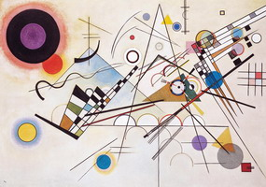
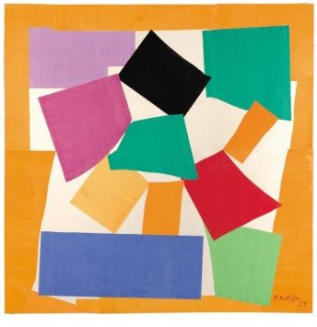
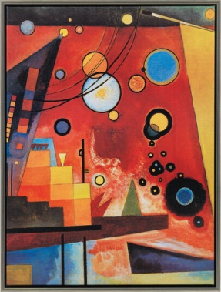

Forever Facts  With practise, technique and control, I can develop my skills in art.  Different methods, colours and a variety of tools and techniques have been used to express mood  Abstract art is art that does not attempt to represent an accurate depiction of a visual reality but instead use shape, colours, forms and gestural marks to achieve its effect  Skills  Develop techniques, including control and use of materials, with creativity, experimentation and an increasing awareness of different kinds of art, craft and design .  Continue to use sketch books to record observations and use them to review and revisit ideas.  Improve mastery of art and design techniques.  Learn and know about Henri Matisse and Wassily Kandinsky create their art work | Exciting Books | Subject Specific Vocabulary  Abstract art Art that doesn't attempt to represent and accurate depiction of reality. Instead it uses shapes, colours, forms and gestural marks  Artist A person who creates paintings or drawings.  Henri Matisse (1869-1954) French artist known for his use of colour. He was a draughtsman, printmaker and sculptor.  Wassily Kandinsky (1866-1944) A Russian painter famous for his colourful abstract art.  SMSC: Spiritual – experience wonder and awe at the achievements of these great works of art. They also experience great admiration and respect for their peers’ work when they see the level of achievement and progress. Moral – They incorporate mutual respect and the consideration for others’ work. Social – working cooperatively, having opportunities to give and receive peer feedback. Cultural – gain an appreciation of different art.
Our Endpoint

To share art work inspired by Henri Matisse and Wassily Kandinsky.

