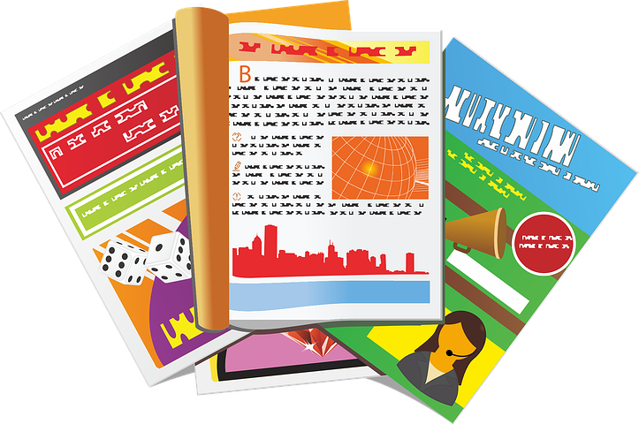
Computing FLE Y3/4 Desktop Publishing (links to English unit)
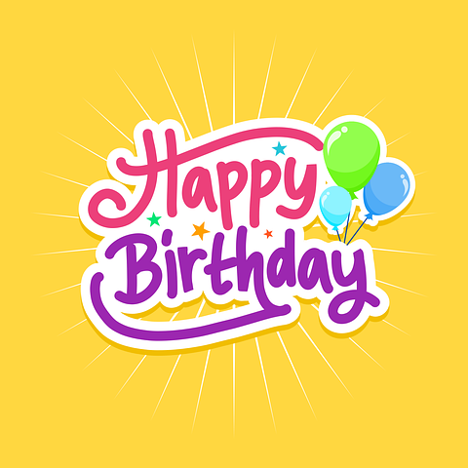
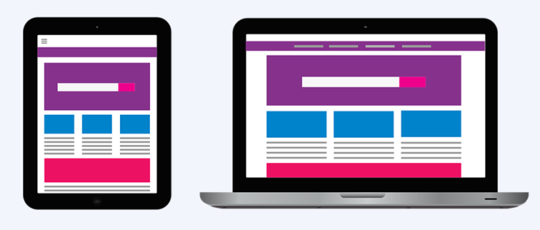

Forever Facts  Test and images are used to communicate messaged more clearly.  You can change text and layout can be changed on desktop publishing.  Information can be presented on a page in different orientations (portrait and landscape).  With desktop publishing, different layouts on suit different purposes (leaflets, magazine covers ect)  Skills  Use search technologies effectively, appreciate how results are selected and ranked, and be discerning in evaluating digital content  Select, use, and combine a variety of software (including internet services) on a range of digital devices to design and create a range of programs, systems, and content.  Evaluate and edit by assessing the effectiveness of their own and others’ writing and suggesting improvements.  Use key phrases in search engines  SMSC: Spiritual – By recognising the power of computers. Moral - reflect on the possible consequences of different actions and situations. Social – Pair and Group Projects. Cultural - By exploring human achievements and creativity using computing worldwide. | Exciting Books  Our Endpoint  To reflect on how desktop publishing is used in the wider world and the benefits it. | Subject Specific Vocabulary  text Text is actual words, whether hand written or typed. We see text used in lots of different ways in the world around us.  images We also call these pictures, graphics, illustrations, but in this unit we will use the term ‘images’. We see images used in lots of different ways in the world around us.  landscape Landscape is when the orientation of a page appears with the longest edge in the horizontal direction.  portrait Portrait is when the orientation of a page appears with the longest edge in the vertical direction.  Page orientation Page orientation is the direction in which a document is displayed or printed. The two basic types of page orientation are portrait (vertical) and landscape (horizontal).  fonts A font is a graphical representation of text that may include a different typeface, point size, weight, color, or design.

