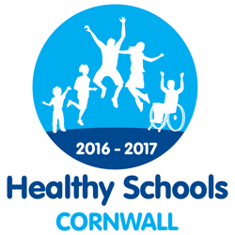
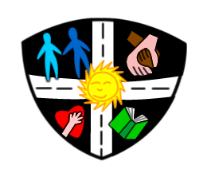
Head Teacher: Mrs Rebecca Norton
Email: head@fourlanesend.cornwall.sch.uk
Website: www.fourlanesendprimary.co.uk
Cawsand, Torpoint Cornwall PL10 1LR
Tel: 01752 822502
Fax: 01752 823407

Fourlanesend C.P. School

Values for Life
Providers of ‘Good’ education
since 2007

2nd June 2020
Dear Parents and Carers
We are really looking forward to welcoming your child back to school and we have been busy preparing for this over the past few weeks. The school building is clear and organised and timetables in place to make it work for all. Obviously we will review daily and weekly once we have put our ideas into practice. We are committed to making it right for all as want the very best for the children in our care. The degree of normality that school can offer will be good for all so we want to get it right. Even though it will not be the same, we have planned and organised activities that will motivate children and prepare them for their learning journeys. We will spend time going through new systems with the children. Due to a very limited uptake, you will notice that we have not staggered the timings, however if numbers increase we will need to review this.
Please read the following very carefully:
Timings
FS/Y1/Y6
Gates open 9.10am
Lessons start 9.15am
Collection time 2.15pm
Key Worker Children
Please inform Mrs Norton of the timings you need
School drop off and collection
Please ensure that only one adult accompanies children to school. We ask all adults to maintain social distancing and to not congregate on the school grounds or surroundings, this also applies to children who walk to school on their own. The government is advising you to walk to school where possible. An adult from each bubble will meet the children at the gate and take their temperature.
Entry/ collection points
EYFS and Y1 - EYFS Gate
Y6 – Side gate
Key worker children – Main Office
Belongings
We would like to keep to a minimum belongings coming from home. However these items are required:
- Coat if cold
- Sun hat
- Sun cream to be applied before they arrive
- Water bottle (water only, nothing flavoured)
- A healthy snack (no sweets, crisps or biscuits and a wrapper they can open)
- Personal tissues
- Home reading book if preferred
Lunch
FS/Y1/FSM/Key workers – your meal will be provided for free by the kitchen. If this is not required please let us know.
Y6 – School dinners are available as an option
If you are sending your child with a packed lunch, please ensure your child can open everything within as staff are not permitted to.
New Systems
The children will be in bubbles supported by a teacher and a TA. These bubbles will be kept separate during the day in their own areas.
We are following the guidance that the most important step to prevent infection is handwashing, so this will become part of the routine many times during the day.
We have set up cleaning supplies around the school and every member of staff will be involved in wiping down regularly.
We have prepared the classrooms and will also be making use of our outside spaces to deliver lessons and activities.
We will be encouraging social distancing but it is important to understand that 2m is not going to be maintained by all pupils at all times. This is why handwashing is so important.
Equipment will be cleaned daily. Soft furnishings have been removed.
A one way system has been put in place in corridors.
Each child will be assigned a toilet to use and additional toilet cleaning procedures have been put in place.
Children will be expected to follow their school values as always. Please see the updated behaviour policy on the website.
How you can help
- It is really important that if any member of your household is showing any symptoms, you do not send your child to school. If any household member has a positive diagnosis the child should be kept isolated for 14 days.
- Please can you send your child in clean home clothes every day. No laces if your child can not tie them independently if possible.
- Do not bring in any unnecessary possessions.
- Do not enter the school building.
- Talk to your child about handwashing, hygiene and social distancing.
- Let us know of any concerns your child has so we can support
- Encourage children to have really positive attitude. Different can be fun and exciting at school.
If you have any questions or concerns please do not hesitate to contact us.

