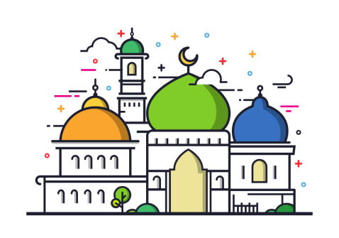
RE FLE Y3/4 Islam
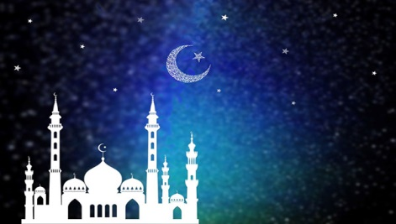
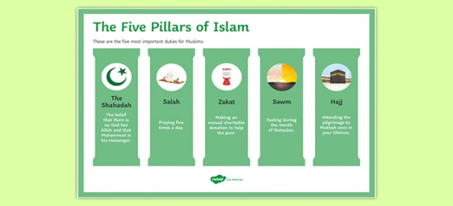

Forever Facts  There is no official symbol of Islam, but the star and crescent symbol is the symbol most commonly associated with Islam.  The Muslim place of worship is called a mosque. Services are held in mosques every day. The most important service for Muslims is on a Friday.  Mosques often have a domed roof. There are no images of people or animals in mosques. They are decorated with patterns and words from the Qur’an.  Muslims take off their shoes before going into the mosque and wash before they pray. Muslims pray kneeling on the floor on a prayer mat. The wall of the mosque which faces Mecca is called the qibla wall. It has an empty arch to show the direction of Mecca.  Muslims take off their shoes before going into the mosque and wash before they pray. Muslims pray kneeling on the floor on a prayer mat. The wall of the mosque which faces Mecca is called the qibla wall. It has an empty arch to show the direction of Mecca.  Mecca is an important place to Muslims. It is where Muhammad was born and the direction that Muslims face when they pray five times a day. Muslims are expected to make a pilgrimage to Mecca once in their lifetime.  To share thoughts on how festivals of worship show what matters to a Muslim.  Skills  I can comment on connections between questions, beliefs, values and practices.  I can describe the impact of beliefs and practices on individuals, groups and communities.  I can describe similarities and differences within and between religions and beliefs. | Exciting Books  Our Endpoint | Subject Specific Vocabulary  Islam Islam is the second most popular religion in the world.  Muslim A follower of the religion of Islam.  Allah The Arabic name that Muslims use for God.  Five Pillars of Islam The five things that Muslims are expected to do.  Prophets Special messengers sent from Allah.  Muhammad The last prophet and the key prophet in Islam.  SMSC: Spiritual – reflect on self-awareness and their own beliefs. Moral - learning about our responsibility for others and thinking about concepts of right and wrong. Social – many opportunities to work collaboratively to share and reflect on their own values and opinions. Cultural - value diversity as they learn about different ways in which communities celebrate and remember important events.  ·

