RE FLE Y3/4 Gospel
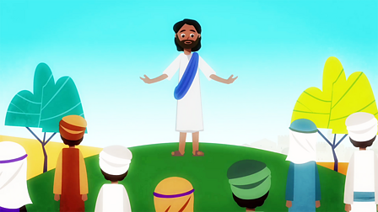

Knowledge within Christianity  Christians believe Jesus challenges everyone about how to live – he sets the example for loving God and your neighbor, putting others first.  Jesus shows love and forgiveness to unlikely people.  Christians try to be like Jesus – they want to know him better and better.  Christians try to put his teaching and example into practice in lots of ways, from church worship to social justice.  Skills  I can identify what Gospel means.  I can make clear links between the calling of the first disciples and how Christians today try to follow Jesus and be ‘fishers of people’.  I can offer suggestions about what Jesus’ actions towards the leper might mean for a Christian.  I can make simple links between Bible texts and the concept of ‘Gospel’ (good news).  To discuss and reflect on the question: What kind of world did Jesus want?  I can give examples of how Christians try to show love to all, including how members of the clergy follow Jesus’ teaching.  I can look at holy texts and stories, explain meaning in a story.  I can make links between the Bible stories studied and the importance of love, and life in the world today. | Exciting Books | Subject Specific Vocabulary  Christianity The religion followed by Christians.  New Testament The second part of the Bible, which was written after Jesus was born.  lent The 40 days leading up to Easter. Christians often give something up for Lent.  disciples A personal follower of Christ during his life.  leper a person suffering from leprosy. Although leprosy can be cured in modern times, it could not be cured in the time of Jesus and there was a huge stigma attached to it.  SMSC: Spiritual – reflect on self-awareness and their own beliefs. Moral - learning about our responsibility for others and thinking about concepts of right and wrong. Social – many opportunities to work collaboratively to share and reflect on their own values and opinions. Cultural - value diversity as they learn about different ways in which communities celebrate and remember important events.
 | Our Endpoint

