Science FLE Y3/4 Sound
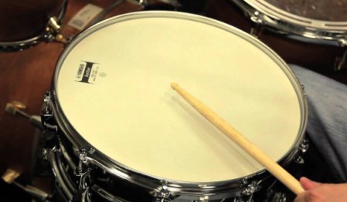

Skills  I can record findings using scientific language.  I can make and record observation.  I can make careful observations and comparisons.  I can ask relevant questions.  Forever Facts  The size of the vibration is called the amplitude. Louder sounds have a larger amplitude, and quieter sounds have a smaller amplitude.  Pitch is a measure of how high or low a sound is. A whistle being blown creates a high-pitched sound. A rumble of thunder is an example of a low-pitched sound.  You can change the pitch of a sound in different ways depending on the type of instrument you are playing.  Sound can travel through solids, liquids and gases. Sound travels as a wave, vibrating the particles in the medium it is travelling in. Sound cannot travel through a vacuum.  Sound energy can travel from particle to particle far easier in a solid because the vibrating particles are closer together than in other states of matter.  Inside your ear, the vibrations hit the eardrum and are then passed to the middle and then the inner ear. They are then changed into electrical signals and sent to your brain. Your brain tells you that you are hearing a sound.  To present findings to an investigation about sound. | Exciting Books  Our Endpoint | Subject Specific Vocabulary  vibration A quick movement back and forth.  sound wave Vibrations travelling from a sound source.  volume The loudness of a sound.  amplitude The size of a vibration. A larger amplitude = a louder sound.  pitch How low or high a sound is.  soundproof To prevent sound from passing through.  absorb sound To take in sound energy. Absorbent materials have the effect of muffling sound.  vacuum A space where there is nothing. There are no particles in a vacuum.  eardrum A part of the ear which is a thin, tough layer of tissue that is stretched out like a drum skin. It separates the outer ear from the middle and inner ear. Sound waves make the eardrum vibrate  SMSC: Spiritual – demonstrate a sense of enjoyment and fascination in learning about themselves, others and the world around them. Moral - show an understanding of the consequences of their behaviour and actions Social – working collaboratively, sharing ideas, data, and results. Cultural – we explore how scientific discoveries have shaped the modern world.  ·

