Art FLE Y3/4 Insects
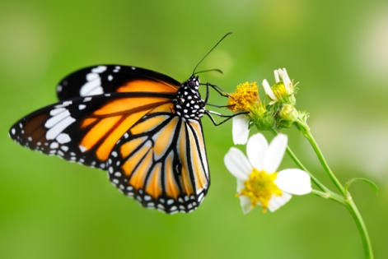
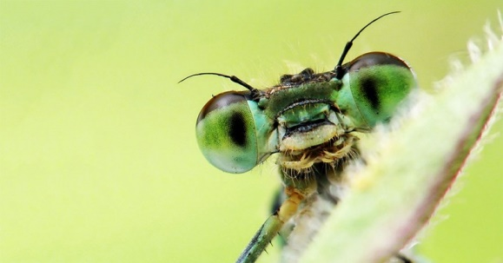
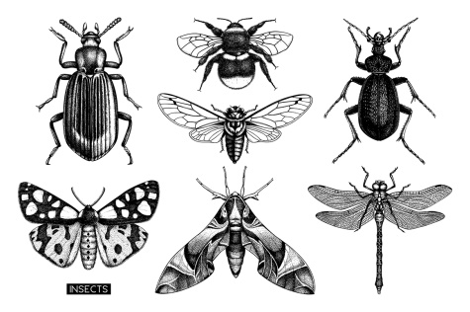

Forever Facts  All insects have 3 body parts: thorax, abdomen and head.  Spiders are not insects, but spiders and insects are arthropods. Unlike insects, spiders do not have antennae.  Louise Bourgeois’ is a French-American artist. Her nickname was ‘Spiderwoman’ because of the spider sculptures that she made. The largest spider was called Maman and reached over 9 metres tall.  Jennifer Angus is a Canadian artist known for arranging insects arranged in ornamental patterns. Angus hopes that her work will make people interested in insects so that more people will help to fight against the destruction of their habitats.  Skills  I can use my sketchbook to record and review ideas.  I can sketch a picture based on observation  I can plan and make a 3D model.  I can learn about great artists. | Exciting Books | Subject Specific Vocabulary  Smudge Smudging is a technique to achieve gradations in shade and tone.  Texture How smooth or rough a painting or artwork may look or feel.  Tone The lightness or darkness of something, this could be a shade or how dark or light a colour looks.  Pattern Repeating a colour or a shade to create an effect of movement or rhythm.  Shape Different shapes in artwork with different shading to create 3D and 2D effects.  Line Lines create an image, these lines can be lighter and darker when sketching.  Form A 3D sculpture form.  SMSC: Spiritual – consider the world around them starting at school. Moral – reflecting on moral decisions which have an impact on insects and their habitats. Social – working cooperatively, having opportunities to give and receive peer feedback. Cultural – gain an appreciation of different art.
Our Endpoint
To create a 3D sculpture of an insect.

