PE FLE Y1/2 Gymnastics
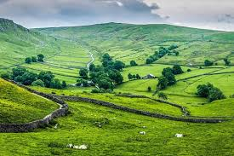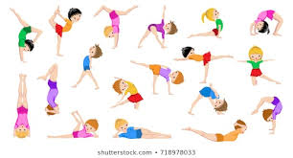
Knowledge  Before we begin any sport or exercise, we need to warm up to prepare our bodies and to avoid hurting our muscles. FF  At the end of any exercise or sport, we need to cool down to help our bodies recover. FF  We can use our bodies to create different shapes, for example, smooth round shapes like hills and tall thin shapes like mountains.  To lift a PE mat safely, we need 4 children, 2 on each long side.  You point the equipment in the direction you want to go.  Always make sure that your pathway is clear when moving equipment.  Create a long thin shape with your body to perform a log roll.  Stand with your feet hip distance apart to perform a straight jump and remember to bend your ankles, knees and hips when landing.  Remember to look around the space when you are travelling.  Regular sport and exercise help us to stay healthy. FF | Exciting Books | Subject Specific Vocabulary  sequence a group of things that come one after another  balance to hold your body position still  flexibility to have the full range of movement in your body  control to be in charge of your body movements  coordination the ability to use different body parts together smoothly  apparatus equipment used for sports activities or exercise  agility to change the direction of your body movement quickly and easily  gymnastics a sport that includes exercise requiring strength, balance, flexibility and agility  Skills  Explore, copy and repeat simple skills and actions  Remember and repeat simple sequences  Begin to move with increasing control and care  Make simple moves with increasing control and coordination
Our Endpoint
A sequence of movements that link town and country together.

