Year 6 Maths

Our focus for the week is: **Scale factors and angles**

Suggested online activities:

<https://whiterosemaths.com/homelearning/year-6/> week 2. There are videos with a question sheet to go with it. If you can print, go ahead, if not (as I have been doing) either talk through the answers with an adult if you are working together, or record them in your book to go through with your adult at a later time. You can always check them yourself against the answers sheet.

There will be tasks set on your mymaths login, you can also get to the lessons that go with these to recap if you need to.

Suggested offline activities:

Can you draw a simple picture and then increase it by a scale factor of 2, 5?

Use the protractor you were given to measure things in the house. Can you find examples of different angles e.g. acute, obtuse, reflex, right-angle? Can you add these together to get as close to a whole (360°) as you can?

It is not expected that you will complete all of this and may well have ideas of your own to explore the topic.

Year 5 Maths

Our focus for the week is: **Decimals to 2 and 3dp**

Suggested online activities:

<https://whiterosemaths.com/homelearning/year-5/> week 1. There are videos with a question sheet to go with it. If you can print, go ahead, if not (as I have been doing) either talk through the answers with an adult if you are working together, or record them in your book to go through with your adult at a later time. You can always check them yourself against the answers sheet.

There will be tasks set on your mymaths login, you can also get to the lessons that go with these to recap if you need to.

Suggested offline activities:

Can you explain how our money system links with numbers to 2 d.p.?

Can you find any examples of decimals being used around the house?

Write your own numbers with 2 and 3d.p. and say what the value of each digit is.

It is not expected that you will complete all of this and may well have ideas of your own to explore the topic.

**English – GPS focus: Passive Verbs**

**Active verbs**Verbs can have an **active** or **passive** voice. When a verb is **active**, the **subject** of the sentence is doing the action. For example:

The cat sat on the mat.  
Here, cat is the **subject**, sat is the **active** verb, and the mat is the object.

**Passive verbs**Contrast this with the **passive** voice of the verb:

The mat was sat on by the cat.  
Here, the mat is the **subject** and is suffering the action of being sat on by the cat.  
Complete the following table, inserting a check mark showing whether the verb is **active** or **passive**.

Suggested online activity:

<https://www.bbc.co.uk/bitesize/topics/zwwp8mn/articles/zsx2b82>. There are videos explaining the focus and a quiz to complete.

Suggested offline activities:

Can you find active verbs in your reading books and change them to passive? Share with an adult.

One activity that works well as an individual or group activity is to draw a pictorial representation of a sentence you create. You must illustrate the sentence in both passive and active voice. For example, "Mary hit the ball over the fence" and "The ball was hit over the fence by Mary." The class decides which sentence is better to include in a writing activity and why.

**Reading: Vocabulary questions.**

When reading your book, if you come across a word you do not understand can you use the context of the sentence/paragraph to work out the meaning? Can you find a synonym for the word? What is an antonym? Why did the author choose that word?

**Science**

Can you compare and group together everyday materials on the basis of their properties, including their hardness, solubility, transparency? Could you put them in order from hardest to softest or from opaque to transparent? Record in your own way, this could be a photo, list, drawing etc.

You can also explore materials online at <https://www.bbc.co.uk/bitesize/topics/z4339j6/articles/zx8hhv4>

PE

Be active as much as possible, it’s good for both your physical and mental health. Online activities include watching (and of course joining in with) Joe Wicks (The Bodycoach) – he is live on youtube every weekday morning at 9 but you can watch the previous videos at any time. Cosmic yoga videos on youtube are great for stretching, the stories may be aimed at a lower age but the nature of the activity is good.

Offline – make up your own fitness circuit and try to beat your record – challenge your family members too.

DT

Focus on balanced meals. Ask to help prepare and cook (under supervision) a meal that has a healthy balance based on the Eatwell plate.

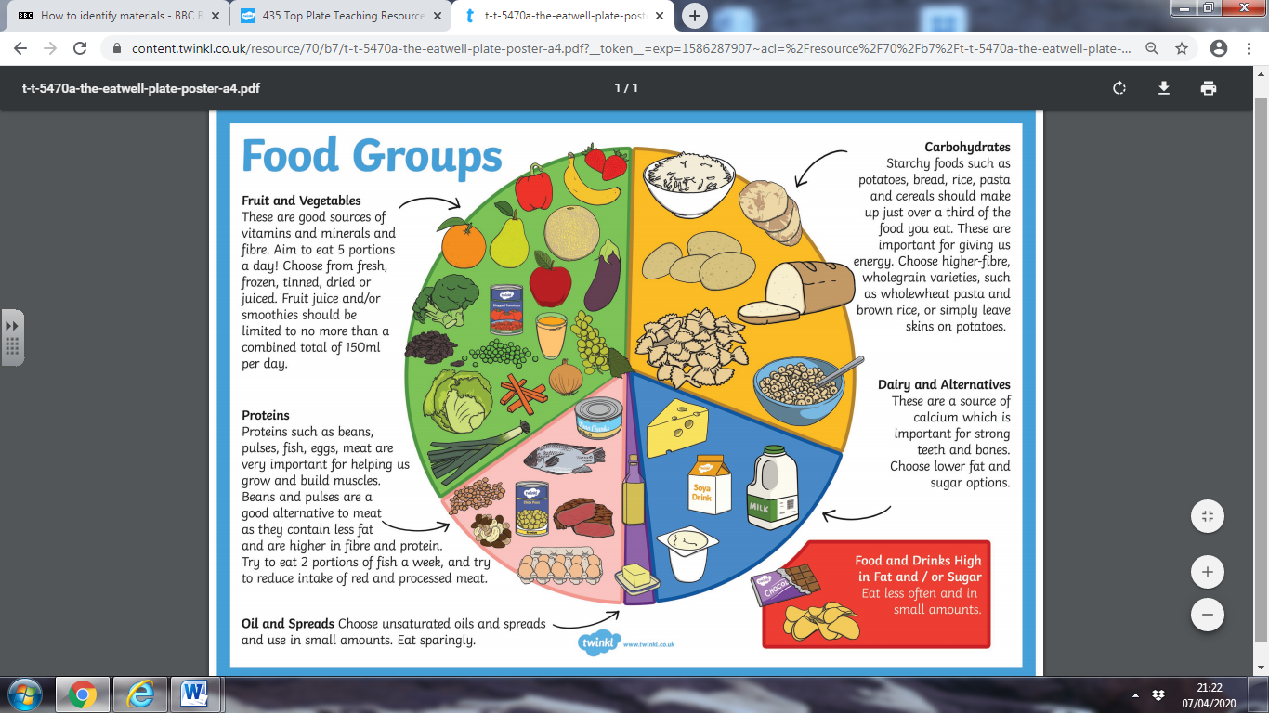

**Computing**

See if you can learn to touch type. This could be a very handy skill for the future.

<https://www.bbc.co.uk/bitesize/topics/zf2f9j6/articles/z3c6tfr>

**Art**

Each week there will be a skill to practice. Be as creative/imaginative as you can.



**Music**

Online - Watch and join along with this interactive video from professional musician Mylene Klass learning about timbre.

<https://www.youtube.com/watch?v=RzE55yauSUo>

Offline – Listen to different types of music and write down words to describe what it sounds like. Do they have anything in common? How do they differ?

**Geography**

Can you identify your favourite place on a map – what sort of maps could you use? Can you describe its location using a map alone?

**British Values** – **Individual Liberty**

Discussion: Why is school important?

We will understand the importance of our education and the opportunities our school can provide and make the right learning choices each day.

**RE Easter**

Watch the What is Easter? film on this webpage.

www.bbc.co.uk/bitesize/topics/ztkxpv4/articles/z4t6rj6

Watch it again and this time note down any important phrases that someone might need explaining. Read through the rest of the web page. Can you explain what these words mean and what Christians think about them to someone who you are living with?

Offline activity:

Draw an image and describe what happens during Holy Week: Palm Sunday, Maundy Thursday, Good Friday and Easter Sunday.

**PSHE – Celebrating diversity.**

