Music FLE Y3/4 Composing
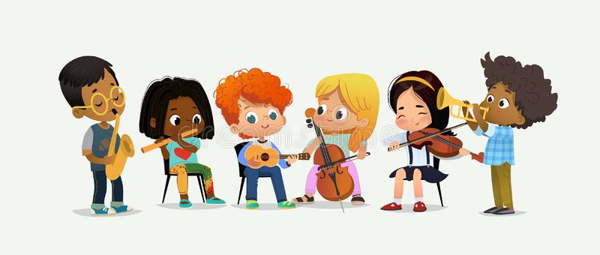
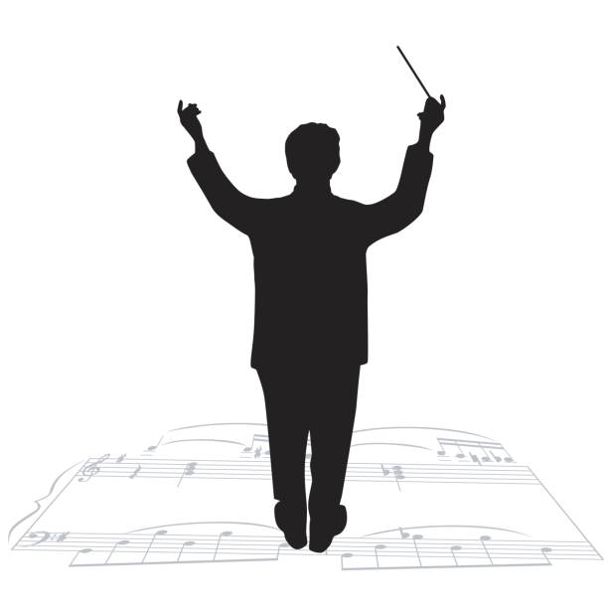
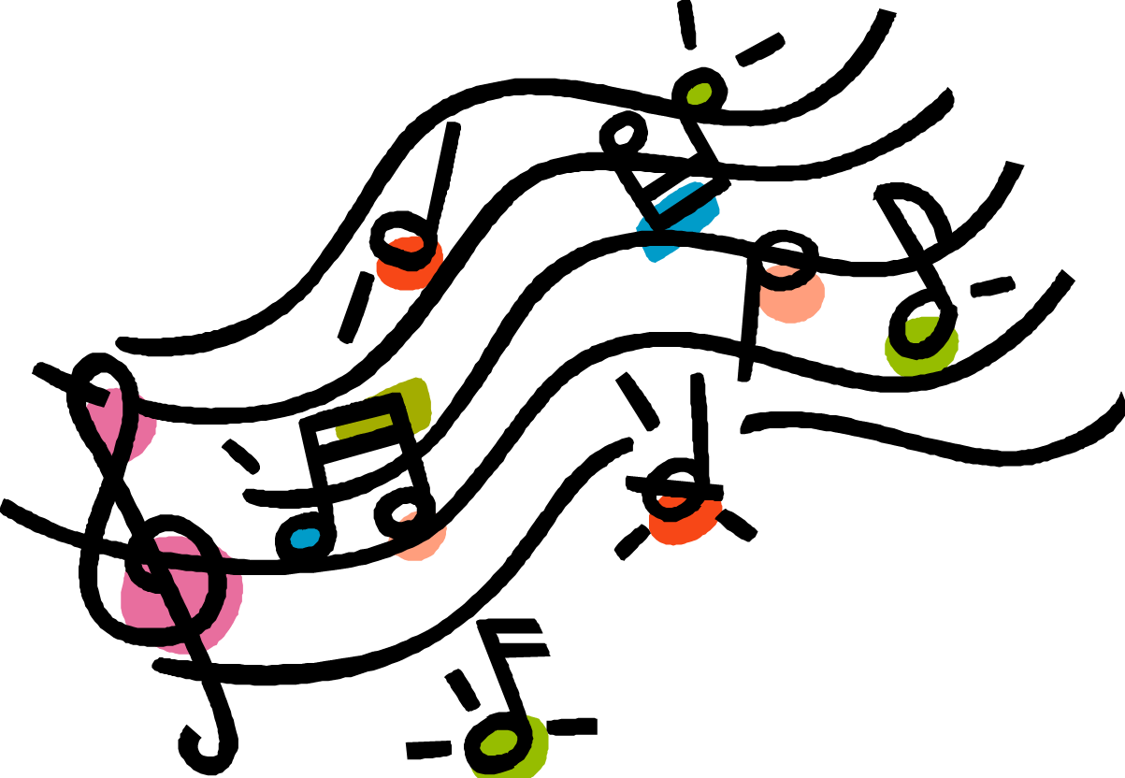

Forever Facts  Different instruments produce different effects.  Different techniques are used in music to have to have a desired effect on the audience.  People interpret music differently.  Skills  How to play as part of an ensemble.  How to create a simple piece of music.  To work in groups to carefully compose a piece of music keeping in mind the desired effect.  SMSC: Spiritual - exposed to music from all cultures and times in history and encouraged to explore their own responses to the music. Moral – considering what might have inspired the work of composers Social – working alongside peers to compose a piece of music. Cultural – participating in musical opportunities. | Exciting Books  Our Endpoint  To perform a short piece of music composed with an effect in mind. | Subject Specific Vocabulary  tempo This means the speed of the music. An exciting adventure film might have music with a fast tempo. A serious, sad film might have music with a slow tempo.  pitch The steady beats in a piece of music. A film about soldiers could have a steady marching beat played on a drum.  dynamics This means whether music is loud or quiet (the musical word for quiet is ‘soft’). Loud music might show something exciting is happening. Quiet music might show a sad event, or maybe even something scary. Music starting quietly and getting louder (the musical term for this is ‘crescendo’) could show that the main point of the film is happening.  pulse The steady beats in a piece of music. A film about soldiers could have a steady marching beat played on a drum.  duration This is the length of notes being played. Short notes could suggest film characters running around. Long notes might suggest a king or queen moving in a stately manner.

