Design Technology FLE Y1/2 Keeping healthy
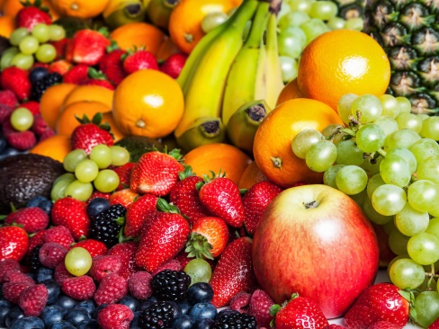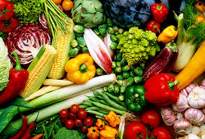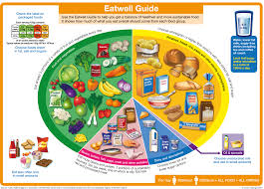
Knowledge  Keeping healthy means caring for your body so you have enough energy to learn, play and grow. FF  All foods contain nutrients which your body needs to stay active throughout the day. Some foods have more nutrients than others. FF  Everyone should have their ‘5 a day’ – this means five portions of fruit and vegetables, to get the right amount of nutrients. FF  It's important not to eat too much sugar and salt: sugary foods are bad for your teeth and salty foods can lead to heart disease. FF  Some vegetables grow above the ground and some grow below the ground. Common vegetables include carrots, potatoes and spinach.  Fruit usually grows on bushes and trees, Common fruits include apples, pears, grapes and bananas.  Some food is caught, for example, fish is caught in seas, rivers and lakes.  Before preparing food, you must wash your hands, remove jewellery and tie your hair up. FF  Use the bridge or claw method to safely prepare fruit and vegetables using a knife.  Remember to prepare food with an adult. | Exciting Books | Subject Specific Vocabulary  healthy keeping healthy means doing things that are good for your body – things like eating nutritious foods, exercising, brushing your teeth and getting enough sleep  diet the food and drink that a person or animal eats  nutrition how a person or animal takes in and makes use of food and drink  hygiene how we prepare food in order to stay safe and healthy  taste to eat or drink a small amount of a food or drink to see what it is like  smell what you notice about something when you breathe through your nose  peel to take off the skin of a fruit or vegetable  chop to cut something into pieces with a knife  Skills  Identify the benefits of eating fruit and vegetables.  Follow basic safety rules.  Use ‘like’ and ‘dislike’ when evaluating and describing.  Use pictures, text and labels to describe and explain.
Our Endpoint
To prepare and make a healthy salad.

