Geography FLE Y1/2 What a Wonderful World
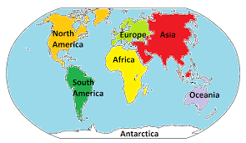
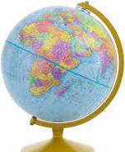

Our Endpoint
Linked to Science; a poster about habitats, continents, animals and their key features.
Forever Facts  The seven continents are Africa, Antarctica, Asia, Australia, Europe, North America and South America.  The five oceans are the Arctic, Southern, Indian, Atlantic and Pacific Ocean.  Europe is the second smallest continent in size.  There are 50 countries in Europe.  Stonehenge and the Eiffel Tower are key landmarks in Europe.  Asia is the largest continent on Earth.  China and India are the countries where most people live.  Mount Everest is a key landmark in Asia.  The Sydney Opera house and The Great Barrier Reef are key landmarks in Australia.  The Sahara desert and the Egyptian Pyramids are key landmarks in Africa. | Exciting Books | Subject Specific Vocabulary  Continent A connected or continuous tract of land  Ocean A big sea  Equator A line that separates the world into the Northern and Southern Hemisphere  Land An area of ground.  Sea A large area of salt water near the land.  Sphere A 3D circle  Globe The Earth.  Climate The weather in an area over a long-period  Skills:  To be able to use a map/atlas/ globe to identify places  To identify key features on aerial photographs  To listen and recall information
SMSC
Spiritual – learning about and appreciating the world around us.
Social – speaking in groups/ team work/ presenting information.

