Music FLE Y3/4 Singing
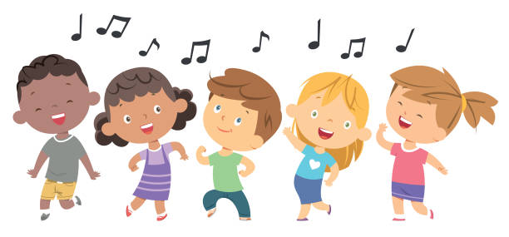

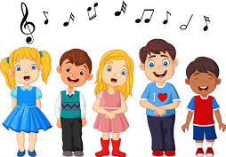
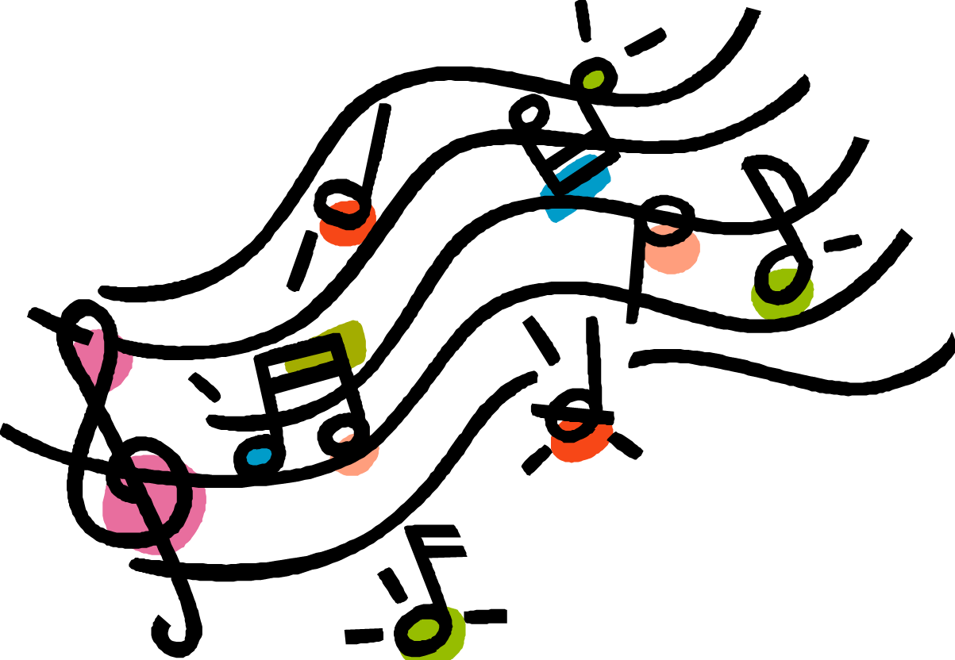
Forever Facts  Understand the relationship between lyrics and rhythm.  To know the techniques used to produce a different range of sounds.  To know how to project our voices to make sound go further.  Skills  I can listen with greater attention to detail.  I can appreciate harmonies, drone and ostinato.  I can recognize how musical elements are used by composers to create different moods and effects.  I can identify beat and pulse in music. | Exciting Books  Our Endpoint  Choose, learn and sing a song in an ensemble. | Subject Specific Vocabulary  lyrics Lyrics are words that make up a song, usually consisting of verses and choruses.  rhythm The rhythm is the actual sound or time value of the notes, which in a song would also be the same as the words.  beat The beat is the steady pulse that you feel in the tune, like a clock's tick. It's the beat you'd naturally clap along to, or tap your foot to.  SMSC: Social – working alongside peers to sing in an ensemble. Cultural – participating in musical opportunities.

