Art FLE Y3/4 Fruit and Vegetables
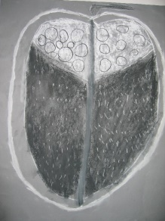
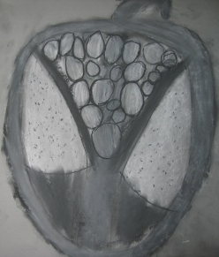
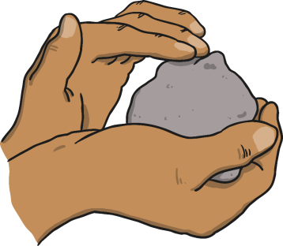
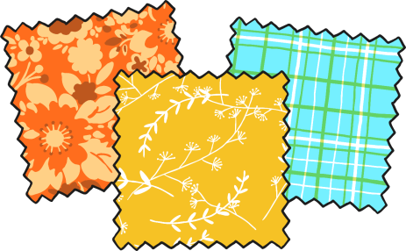
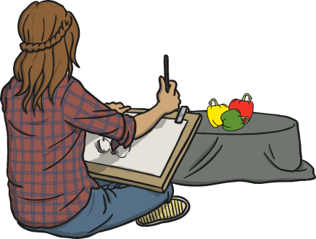

Forever Facts  To learn about great artists, architects and designers in  History.  To use sketch book in order to review and revisit ideas.  Skills  To improve mastery of art and design techniques, including drawing, clay and painting.  To improve mastery of art and design techniques.  To create Fruit and Vegetable ‘Softies’ on Fabric.  What I have learnt before:  Use drawing, painting and sculpture to develop and share their ideas, experiences and imagination.  Develop a wide range of art and design techniques in using colour, pattern, texture, line, shape, form and space. | Exciting Books | Subject Specific Vocabulary  tone light and dark shades of a colour.  smudge Smudging is to rub, dab or swipe in a smeary manner. Smudging is very common in drawing portraits.  form In terms of art, form refers to objects that are 3-Dimensional, or have length, width, and height. The world we live in made up almost entirely of forms.  design A plan or drawing produced to show the look and function of something before it’s made.  evaluate Evaluating is the process of deciding if you've done something the best way, and looking at what could be improved.  Culture capital: an appreciation of the arts, creativity and culture allowing children to have the confidence to engage in conversations about art.
 | Our Endpoint

