DT FLE Y3/4 Making Volcanoes
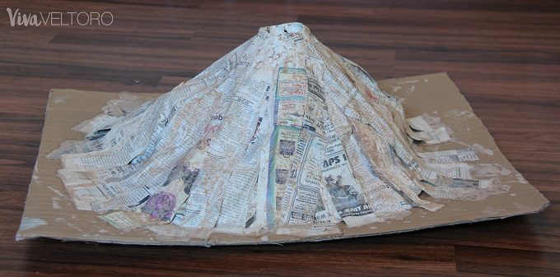
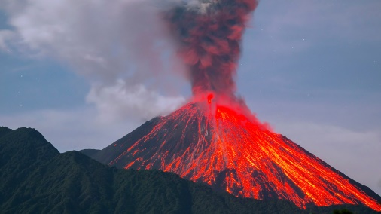

Forever Facts  To understand how pneumatic systems work.  Develop and use knowledge of how to construct strong, stiff shell structures.  Develop and use knowledge of nets of cubes and cuboids and, where appropriate, more complex 3D shapes.  Know and use technical vocabulary relevant to the project.  Skills  I can investigate how pneumatic systems work and incorporate this in my design.  Use annotated sketches, prototypes, final product sketches and pattern pieces; communication technology, to develop and communicate ideas.  Plan the main stages of making  Select from and use a range of appropriate utensils, tools and equipment with some accuracy related to their product.  To make and evaluate a model of an erupting volcano in small groups.  Select from and use finishing techniques suitable for the product they are creating.  Test their product against the original design criteria and with the intended user.  Evaluate the ongoing work and the final product with reference to the design criteria and the views of others. | Exciting Books | Subject Specific Vocabulary  pneumatics Pneumatics is the use of compressed air for mechanical motion  volcano A volcano is an opening in the Earth's crust that allows magma, hot ash and gases to escape.  mechanism A mechanism modifies input forces and movement into a set of output forces and movement that the user desires.  design A plan or drawing produced to show the look and function of something before it’s made.  evaluate Evaluating is the process of deciding if you've done something the best way, and looking at what could be improved.  SMSC: Spiritual – reflect on self-awareness. Moral - learning about our responsibilities within a group. Social – many opportunities to work collaboratively to share and reflect on their own values and opinions. Cultural - value diversity when working in groups.
 | Our Endpoint

