Music FLE Y3/4 Rap-time
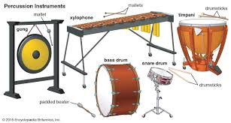
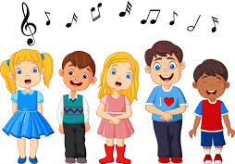
To create their own rap in small groups [bands].
Our Endpoint
Knowledge  Different types of music can make us feel different emotions.  Percussion instruments keep the rhythm and make special sounds which add excitement to a piece of music.  Our bodies can also create percussion sounds, for example, clapping our hands or patting our knees. FF  Tuned percussion instruments include the piano, glockenspiel and hand chimes. FF  Untuned percussion instruments include cymbals, drums and scrapers. FF  When we talk or sing, sounds are made by our vocal cords vibrating (moving) in our throat. FF  If we sing a note with a low pitch then our vocal cords are moving slowly.  If we sing a note with a high pitch then our vocal cords are moving quickly.  If a piece of music has a high tempo then the beats will be close together – it will sound fast.  If a piece of music has a low tempo then the beats will be far apart – it will sound slow. | Exciting Books | Subject Specific Vocabulary  Rhythm a regular repeated pattern of beats, sounds, activity or movements  Tempo the speed which we play at or sing at  Instrument something that produces music  Body Percussion Sounds made using your body  Composition a piece of music  Lyrics Words to a song  Pitch the highness or lowness of a sound  Unpitched Percussion Skills Create and choose sounds in response to different starting points. Create short melodic patterns and rhythmic phrases. Beat out short rhythms and repeat rhythmic patterns. Sing simple songs from memory. Percussion instruments that don’t have pitches. Eg, drum or wood block.
SMSC
Social – working alongside peers in ‘band’.
Cultural – participating in musical opportunities.

