Computing FLE Y1/2 Word-processing
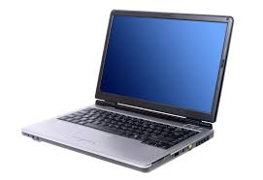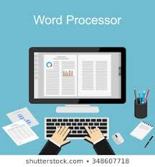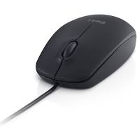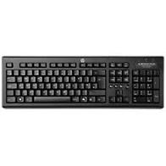
Knowledge  Computers can be used to store information. FF  A word-processing program can be used to type text, for example, a story, a set of facts or a set of instructions. FF  Use two hands to type on the keyboard.  Use one space at the end of each word and after a full stop.  Hold down the shift key for a capital letter.  Carry on typing at the end of a line unless it’s the end of a paragraph, a title or a poem.  You can save your work in a folder and then retrieve it at another time.  You can print your work.  You can use the arrow keys to move around the text.  You can make changes to your text, for example, choose a different font, make the letters bigger or smaller as well as making the letters bold or different colours. | Exciting Books | Subject Specific Vocabulary  keyboard A set of keys that help you to operate a computer.  type Writing something using the keys on a computer keyboard.  save To keep or store something.  folder A way of storing and organising things.  document A written or printed record of something.  bold Something that has a strong or clear appearance.  font The way the letters look – each font has a different shape, for example, Comic Sans or Times New Roman.  Skills  Recognise different ways of using IT and decide which to use.  Use the space bar.  Store documents into a folder and retrieve them.  Write simple ideas and make lists.
Our Endpoint
Use our typing and editing skills to create fact boxes for a poster.

