Art FLE Y1/2 Colour Chaos
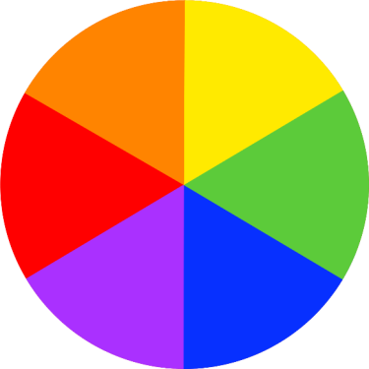
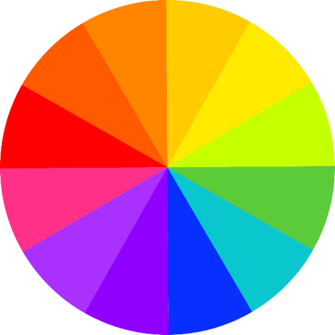
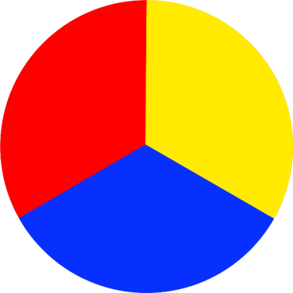

Knowledge  The primary colours are red, yellow and blue. FF  Primary colours cannot be made by mixing any other colour. FF  Mondrian liked to paint using the primary colours with black lines and white spaces.  A tint is made by adding white to a colour to reduce darkness. FF  A shade is made by adding black to a colour to increase darkness. FF  Jackson Pollock invented ‘drip painting’.  Secondary colours are made by mixing primary colours together. FF  Warm colours make us think of sunny, warm and cosy things.  Cool colours make us think of fresh, calm and chilly things.  Kandinsky often listened to music whilst he painted and tried to paint what he heard. | Exciting Books | Subject Specific Vocabulary  mixing Putting different things together to make something new.  abstract art Art that uses shapes and colour instead of accurate depictions of reality.  collage A piece of art that is made by sticking different materials such as paper or fabric onto a backing.  artist A person who creates paintings or drawings as a profession or hobby.  paint A coloured substance which is spread over a surface and dries to leave a thin decorative or protective coating.  paintbrush A brush for applying paint  sponge An absorbent material used by artists to create different effects.  Skills  Know how to create a collage.  Know the primary colours and how to mix the secondary colours.  Communicate ideas simply.  Describe how they feel about their own and other’s work.
Our Endpoint
To create our own piece of work in the style of our chosen artist.

