RE FLE Y3/4 Christianity
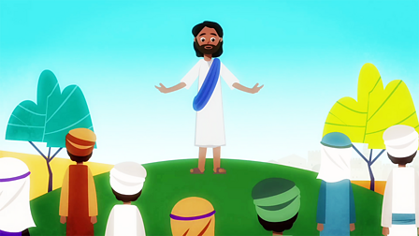
What I have learnt before:
Different symbols that show we belong (like our uniform) Plants need light, air, water and food in order for them to grow.

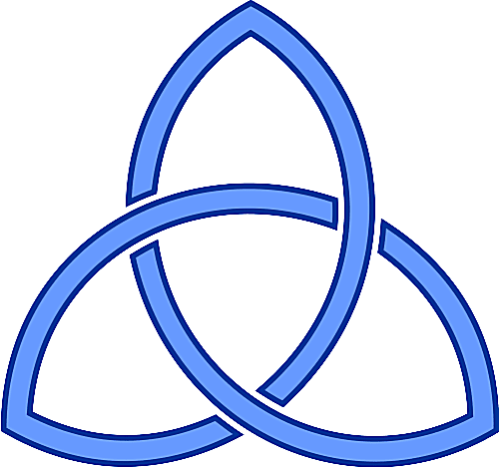
Knowledge within Christianity  Christians believe the good news is not just about setting an example for good behaviour and challenging bad behaviour: it is that Jesus offers a way to heal the damage done by human sin.  Christians believe that they should bring this good news to life in the world in different ways, within their church family, in their personal lives, with family, with their neighbours, in the local, national and global community.  To explain connections between biblical text.  Recognise what a ‘Gospel’ is and give an example of the kinds of stories it contains.  Skills  Offer suggestions about what texts about baptism and Trinity mean.  Give examples of what these texts mean to some Christians today.  Raise important questions and suggest answers about how far the beliefs and practices studied might make a different to how pupils think and live.  To discuss and reflect on the question: What is the ‘trinity’ and why is it important to Christians?  Give good reasons for the views the have and connections they make. | Exciting Books | Subject Specific Vocabulary  Christianity The religion followed by Christians.  New Testament The second part of the Bible, which was written after Jesus was born.  Baptism Baptism is a ceremony that symbolises a commitment to living a life as a Christian  Trinity The Trinity is an idea used to explain that three different persons are called God: God the Father, God the Son, and God the Holy Spirit (who is sometimes called the Holy Ghost). Trinity states that these three all form the same God.  Gospel The word gospel means “good news,” and gospel songs often praise God or Jesus.  Culture capital: reflect on self-awareness and their own beliefs. Moral - learning about our responsibility for others and thinking about concepts of right and wrong.
 | Our Endpoint

