Geography FLE Y1/2 The UK
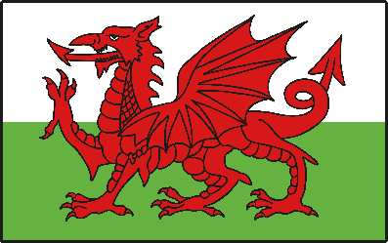
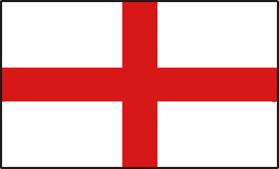

Northern Ireland
Wales
Scotland
England
Knowledge  In the countryside you will find fields, woodland, rivers, lakes and farms.  In the town you will find a high street, office blocks, shopping centres and football stadiums.  The United Kingdom includes the countries: England, Scotland, Northern Ireland and Wales. FF  England is the largest country in the UK and the capital city is London. FF  Many parts of England are flat and there is also lots of countryside with rolling hills and valleys.  Scotland is a country in the North of the UK and the capital city is Edinburgh. FF  Scotland has a very rugged landscape with many hills, mountains and lakes called ‘lochs’.  Wales is a hilly country with many valleys and the capital city is Cardiff .FF  Northern Ireland is the smallest country in the UK and the capital city is Belfast. FF  The major seas around the UK are the North Atlantic Ocean, the North Sea, the Irish Sea and the English Channel. FF | Exciting Books | Subject Specific Vocabulary  countryside land that is away from towns and cities  village a small town  town a place with a lot of streets, houses and shops  city a very big town where a lot of people live and work  valley a low area of land between hills  hill a piece of land that is higher than the land around it  landmark a building or place that is easily recognised  sea a large area of salt water near the land  ocean a big sea  Skills  Identify features on a map.  Identify key regions of the British Isles.  Describe physical and human features of places.  Understand similarities and differences.
Our Endpoint
A collaborative poster showing the key features of the UK.

