Music FLE Y3/4 Composing - Rhythmic Patterns
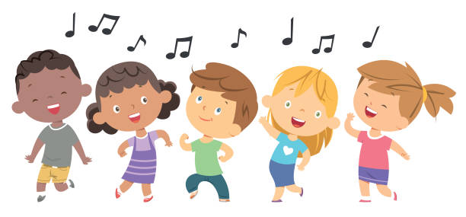
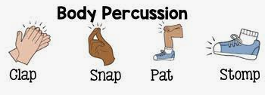
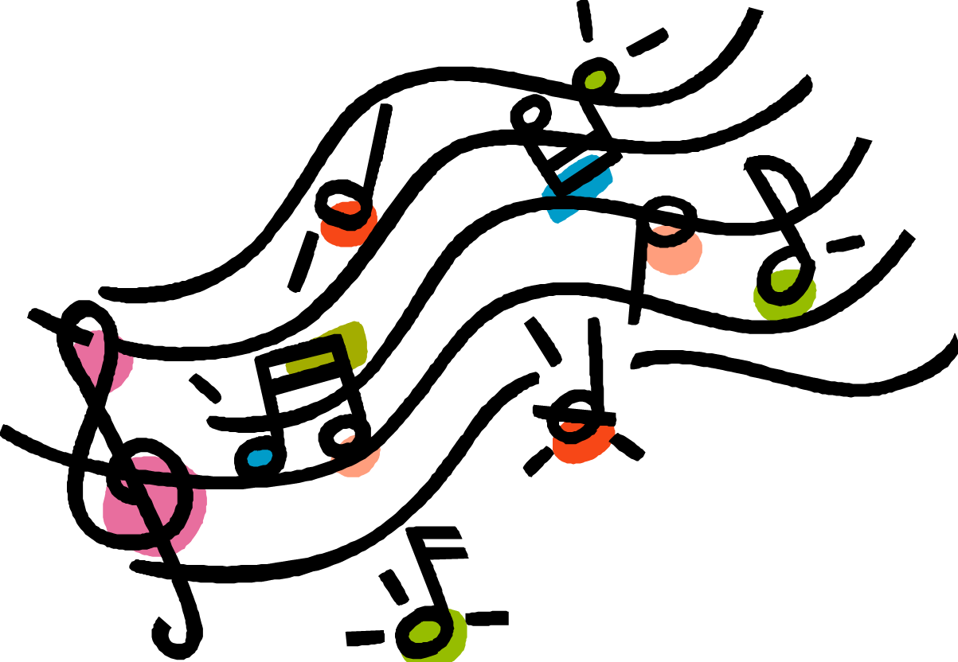
What I have learnt before:
Different types of music can make us feel different emotions.

Our bodies can also create percussion sounds, for example, clapping our hands or patting our knees.

Forever Facts  Recognise pattern in music.  To know the techniques used to produce a different range of sounds.  Understand of different parts and know how to make  improvements to their work.  Skills  To perform a repeated pattern to a steady pulse.  Improvise within a group.  Improvise repeated patterns.  Compose lyrics to fit set rhythm patterns.  Order sounds within simple structures (beginning, middle, end) . | Exciting Books  Our Endpoint  To perform the accompanied version of the Clean school rap. | Subject Specific Vocabulary  pulse Pulse and beat are often used synonymously. Both refer to the regular heartbeat of the music – the ‘steady beat’. We have opted to use the word beat throughout whether it is played or felt.  ostinato (plural - ostinatos/ ostinati) a short rhythmic or melodic pattern that is repeated over and over.  rest a silence.  rhythm Patterns of long and short sounds played within a steady beat.  body percussion Sounds that can be made using parts of the body, eg clapping, tapping knees ...  improvise inventing music as you go along  Culture Capital: working alongside peers and participating in musical opportunities.

