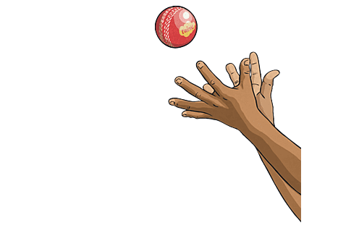
PE FLE Y3/4 Multi-skills
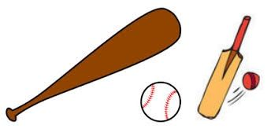

Skills  To strike a ball with intent to advance a game.  To choose and use a range of strategies for striking and fielding.  To develop strategies to catch and return the balls to advance the game.  To develop the accuracy of their throwing skills at targets.  To develop the accuracy of their catching skills with a bean bag and a ball.  Forever Facts  Understand the importance of rules and fairness.  Understand what effects exercise has on our bodies.  Understand the importance of warming up and cooling down.  Understand how performances can be improved through practise and reflection. | Exciting Books  Our Endpoint  To demonstrate an understanding of the key skills learned. | Subject Specific Vocabulary  under arm Underarm throw involves a backward-forward swing of the hand to release a ball.  strike To hit the ball forcibly and deliberately with the bat.  tactic An action or strategy carefully planned to achieve a specific end.  fielding An attempt to catch or stop the ball and return it after it has been hit by the batsman or batter.  cupped hands To shape hands into a cup to catch the ball.  SMSC: Spiritual – students are continually encouraged to be creative and use their imagination. Moral - students are regularly working together in groups. Social – working collaboratively to use both their skills in a range of different contexts. Cultural – students are regularly encouraged to appreciate a wide number of cultural influences.  ·

