Science FLE Y3/4 Plants
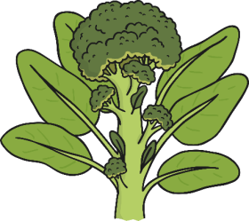
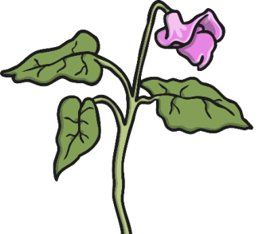
What I have learnt before:
There are different types of habitats where plants grow (e.g. woodland, coastal, rainforest) .
Plants need light, air, water and food in order for them to grow.

Skills  I can classify simple features.  I can record findings using scientific language.  I can make and record observation.  I can make careful observations and comparisons.  I can ask relevant questions,  Forever Facts  The flowers job is to create seeds so that new plants can be grown.  The life cycle of the plant:  - Germination;  - Growing and flowering;  - Pollination;  - Fertilisation and seed formation;  - Seed dispersal.  Seeds can be dispersed by:  - Water  - Shaking  - Bursting  - Eating  - Carrying  - Dropping.  Different plants vary in how much things they need. For example, cacti can survive in areas with low water, whereas water lilies need to live in water. | Exciting Books  Our Endpoint  Culture capital: The jobs it can be used in are: conservation scientist, farming, plant biologist. Children will learn to appreciate and embrace our local environment.  ·  To understand the stages of the life cycle of a flowering plant. | Subject Specific Vocabulary  roots These anchor the plant into the ground and absorb water and nutrients from the soil.  stem This holds the plant up and carries water and nutrients from the soil to the leaves. A trunk is the stem of a tree.  leaves These make food for the plant using sunlight and carbon dioxide from the air.  flowers These make seeds to grow into new plants. Their petals attract pollinators to the plant.  nutrients These substances are needed by living things to grow and survive. Plants get nutrients from the soil and also make their own food in their leaves.  evaporation When a liquid turns into a gas.  fertilisation When the male and female parts of the flower have mixed in order to make seeds for new plants.  pollination When pollen (a fine powdery substance produced by a flowering plant) is moved from the male anther of a flower to the female stigma.  germination When a seed starts to grow.

