Computing FLE Y3/4 Programming
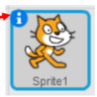
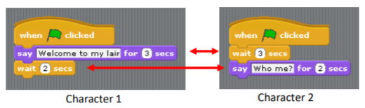

Forever Facts  A command is an instruction given by a user telling a computer to do something, such as run a program. Commands are usually issued by typing them in or inserting a command ‘block’.  ‘debug’ is when I correct mistakes in programing.  Skills  Design, write and debug programs that accomplish specific goals, including controlling or simulating physical systems; solve problems by decomposing them into smaller parts.  I can use sequence, selection and repetition in programs.  I can work with variables and various forms of input and output. | Exciting Books  Our Endpoint  For 2 characters to take part in a programmed conversation. | Subject Specific Vocabulary  debug Correcting mistakes in programming.  sequence A set of instructions that are followed in order  programs Instructions written in language (code) that a computer will understand.  input The way a computer receives data (keyboard, mouse, touchscreen).  algorithms A sequence of instructions or a set of rules that are followed to complete a task. The task can be anything, but clear instructions must be given for the task.  SMSC: Spiritual – By recognising the power of computers by making lego move. Social – Pair and Group Projects. Cultural - By exploring human achievements and creativity using computing worldwide.

