RE FLE Y3/4 Christianity
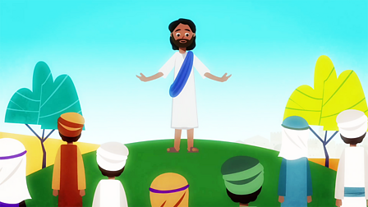
Skills
I can describe the key beliefs and teachings of Christianity.
I understand what belonging to a religion might look like, through practices and rituals, and what it might involve.
I can discuss and present thoughtfully my own and others’ views.
I can develop my appreciation of the ways in which people’s values are an important aspect of their lives.
I can explore how an appreciation of religion plays an important role in the lives of some people.
I can look at holy texts and stories, explain meaning in a story.

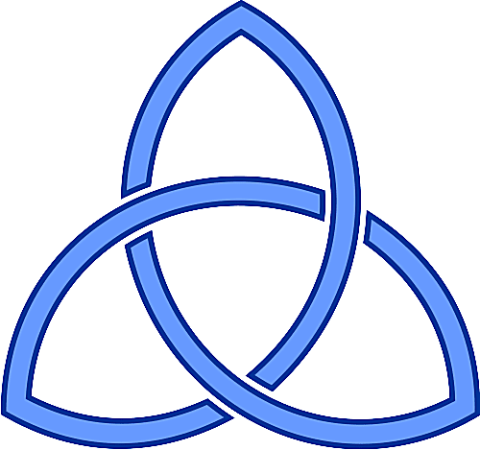
Forever Facts  Christianity is one of the five main world religions. It began after the death of Jesus.  The words ‘Christian’ and ‘Christianity’ come from the name, ‘Jesus Christ.’  Jesus is also known as Jesus Christ, Jesus of Nazareth, The Good Shepherd, Lamb of God, Light of the World, and Bread of Life.  Christians believe in the Trinity. There is one God, but He is three separate people: Father, Son and Holy Spirit. The Holy Spirit is sometimes known as the Holy Ghost.  The Ten Commandments were given by God. They can be found in the Old Testament. Christians try to live their lives by following the Ten Commandments.  Some Christians pilgrimage to holy places, such as Jerusalem (where Jesus died), Bethlehem (where Jesus was born) and Nazareth (where Jesus grew up).  Catholics may pilgrimage to Lourdes, in France, where miracles were said to have occurred, or Rome, in Italy, where the Pope (the head of the Catholic church) lives.  To listen to and share thoughts about the creation story.  Easter and Christmas are important Christian festivals. Christmas celebrates Jesus’ birth and Easter celebrates Jesus’ death and resurrection.  The Christian holy book is the Bible. It has two parts: the Old Testament and the New Testament.  SMSC: Spiritual – reflect on self-awareness and their own beliefs. Moral - learning about our responsibility for others and thinking about concepts of right and wrong. Social – many opportunities to work collaboratively to share and reflect on their own values and opinions. Cultural - value diversity as they learn about different ways in which communities celebrate and remember important events. | Exciting Books | Subject Specific Vocabulary  Christianity The religion followed by Christians.  Judaism The religion followed by Jews.  Jesus The founder of Christianity.  Ten Commandments Ten rules given by God for people to live by.  The Trinity The three separate forms that God is known by.  Old Testamen The first (and biggest) part of the Bible, written before Jesus was born.  pilgrimage A journey to visit a religious site.  Catholic A member of the Roman Catholic church – a denomination (group) of Christianity.  miracles Amazing events that occur, but cannot be explained.  resurrection When Jesus rose from the dead.  Lent The 40 days leading up to Easter. Christians often give something up for Lent.  New Testament The second part of the Bible, which was written after Jesus was born.
 | Our Endpoint

