PE FLE Y1/2 Starry Skies
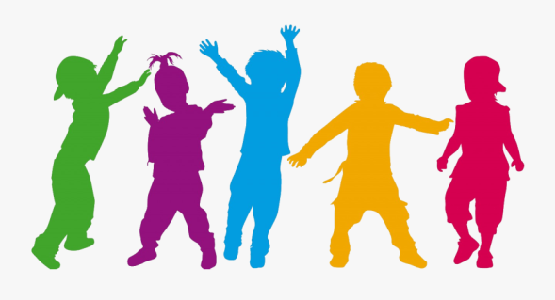
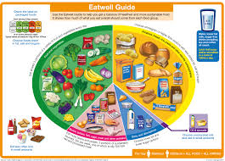
Our Endpoint
To create and perform a dance
Knowledge  Keeping healthy means caring for your body so you have enough energy to learn, play and grow. FF  Regular sport and exercise help us to stay healthy. FF  We must dress appropriately for PE to ensure that we and others, are safe. FF  Stretching keeps the muscles flexible, strong and healthy. FF  Everyone should have their ‘5 a day’ – this means five portions of fruit and vegetables, to get the right amount of nutrients. FF  All foods contain nutrients which your body needs to stay active throughout the day. Some foods have more nutrients than others. FF  It's important not to eat too much sugar and salt: sugary foods are bad for your teeth and salty foods can lead to heart disease. FF  Dancing is a form of exercise but doesn’t always feel like it! FF  Gravity is the force that pulls things towards the Earth – us included! FF | Exciting Books | Subject Specific Vocabulary  healthy keeping healthy means doing things that are good for your body – things like eating nutritious foods, exercising, brushing your teeth and getting enough sleep  exercise to be physically active  active to move  control to be in charge of your body movements  coordination the ability to use different body parts together smoothly  balance The distribution of weight to ensure that we are able to stand upright and steady  performance The act of presenting your work to others  Skills  Copy and repeat simple skills and actions  Understand the importance of being active.  Talk about how to exercise safely.  Begin to move with increasing control and care  Link simple moves with increasing control and coordination
SMSC
Social – Giving peers space to move; watching peers perform
Spiritual – participate in ‘musical’ activities

