The Ugly Duckling – 18.5.20
Can you write me a book review for this book? Characters, title, plot, rating out of 5 or 10.
Maths
Year 1- https://wrm-13b48.kxcdn.com/wp-content/uploads/2019/SoLs/Primary/Summer_Term_SOL/Year-1-2018-19-Summer-Block-1-Multiplication-and-Division.pdf
Pages 13-16
https://whiterosemaths.com/homelearning/year-1/
There are some really informative and visual videos on here which will be excellent recapping.
_________________________________________________________
Can you go on a nature walk around where you live and see if you can spot any ducks/ducklings? How many do you see each day? Keep a tally and total it up each day.
Reception maths
You are more than welcome to have ago at the year one tasks too.
Can you start exploring the clock/s in your house? A watch.. look at the numbers and hands. Do you know any times? Start looking at 0clock times. What time do you get up, does school begin, is lunch, evening dinner, bedtime..
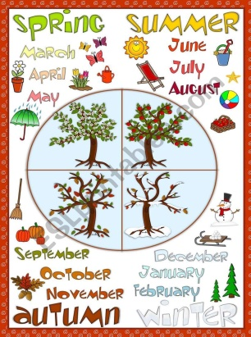
https://www.youtube.com/watch?v=NS-2dUpkoHA
https://www.topmarks.co.uk/Search.aspx?q=telling+time
Science/writing/art
Can you name the four seasons? Can you research what happens in each and what months fall into them? Create a page with a season in each and pictures, labels, summaries of each season. Something like this -
In the story, lots of other animals are not very kind to the ugly duckling and I think they need reminding. Can you write me a piece about how to be a good friend? Think to our helping hands poster that we made at school. Share things, ask how they are, listen etc.. they need to remember their Kindness family!
The poor ugly duckling gets cold during winter. Can you use some old material/fabric/paper/tissue paper to create some nice and warm clothes for him? He might need a scarf, hat, gloves..
Can you make a list of animals that you know hatch from eggs.. and then research some others and try to discover some new ones. How many did you find?
Regular letter formation practice – for EVERYONE. I’ve loved seeing your writing and have noted that we all seem to be muddling up some of the directions of our sounds and I can see when pencils have been taken off! https://www.youtube.com/watch?v=ijd45Qddxfo this has all of the alphabet and the mnemonics to form them correctly. This could be a daily activity.
PE –
-Daily Joe Wicks PE at 9am on you tube
-Cosmic yoga on you tube
-Laps of your garden – try to improve how many you can do each day/week.

BBC bitesize - https://www.bbc.co.uk/bitesize/subjects/z6svr82 Are posting daily lessons.
Find out about desert habitats!

Writing challenge – instructions on how to make a sandwich. (Can you make one with an adult. You might want to draw boxes and write captions for pictures, bullet points, numbers..)

