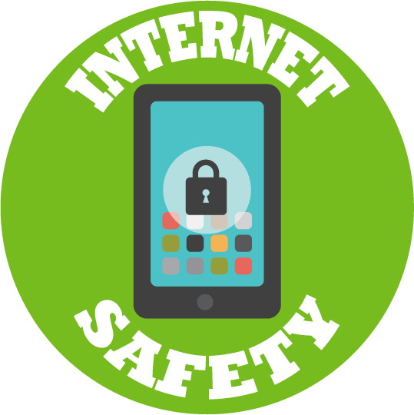
Computing FLE Y3/4 Internet Safety
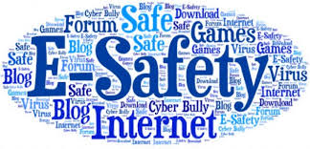
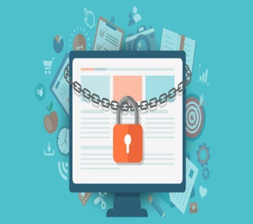
Skills
I can use technology safely, respectfully and responsibly.
I can recognise acceptable/unacceptable behavior online.
I can identify a range of ways to report concerns about content and contact.
I understand computer networks including the internet and how they can provide multiple services.

Forever Facts  We might use the word ‘bullying’ to describe when somebody is intentionally mean or unkind, more than once, to another person.  We might use this word to describe when someone uses digital technology to be intentionally mean or unkind to someone more than once.  If you think you or someone you know is experiencing cyberbullying, tell an adult with whom you feel safe and comfortable.  A big difference between a real-life community and an online community is that people all over the world can communicate with anyone else instantly. They can communicate by using chat rooms, social media, comments, and even games forums.  Just because something is on the Internet doesn’t mean that it is true. Some people create spoof websites that pretend to be something else such a bank website or to provide misleading information.  Targeted advertising is when companies use your digital footprint to see what kind of toys you might be interested in and then make sure that you see those adverts more often.  Passwords stop people from getting into your account, but they also stop people from seeing any private information that might be in your account. | Exciting Books | Subject Specific Vocabulary  Cyberbullying The bullying of another person using the internet, mobile phones and other digital devices, with the intent to deliberately upset them.  Email Messages sent by electronic means from one device to one or more people.  Password A secret word, phrase or combination of letters, numbers and symbols that must be used to gain admission to a site or application such as a website.  Online Communities a group of people with common interests who use the internet to communicate (email, web sites, instant messaging).  Online Safety Refers to staying safe when having a presence online.  Secure Keeping personal information online safe.  Social Media network An online platform that allows users to create a public profile and interact with other users on the website.  SMSC: Spiritual – reflecting on their own lives and the lives of others. Moral – consider the effects of social networking and the consequences of cyber bullying. Social – develop their team working skills through collaborative work and research. Cultural - think about how differing cultures access and use the internet and what implications this has on the individual and the culture.
Our Endpoint

To plan a party applying what we have learned about online safety.

