PE FLE Y3/4 Dance
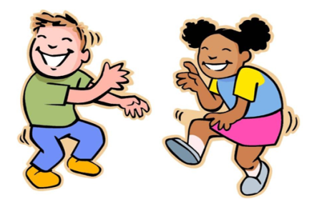
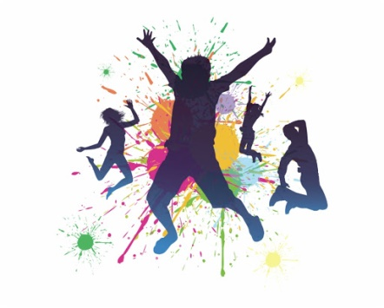

Forever Facts  Basic body actions are the foundations that help make up the  movements of a dance routine. These include step, gesture, travel, stillness, jump and turn. By putting these together, in whatever order you choose to make it flow, you can create a simple dance routine very easily.  Performing a movement/action needs to be done within a count and is usually over a count of 4, 8, 16 or 32. By doing this it creates a structure and provides control to the routine as it keeps it looking good and not completely random!  Timing can be either simply keeping the movements and counts to accompany the music or whether a pair/group are in unison. Keeping in time relies on the performer to listen to the music, keep the counts to the beat of the music and use their movement memory!  Knowing the trigger is important in both individual and group  dances. A trigger can be a specific part of the music, someone else’s specific movement which indicates the beginning of your movements. Picking out specific parts as a trigger helps remember the routine.  Skills  I can copy an action and explain how it communicates an idea.  I can put actions together to tell a story.  I can perform a number or movement phrases in unison and canon within a group.  I can show awareness of control when performing.  I can perform suggested movement phrases to communicate ideas.  I can evaluate movement phrases ready for performance. | Exciting Books  Our Endpoint  SMSC: Spiritual – students are continually encouraged to be creative and use their imagination. Moral - students are regularly working together in groups. Social – working collaboratively to use both their dance and social skills in a range of different contexts. Cultural – students are regularly encouraged to appreciate a wide number of cultural influences.  ·  To compose and perform a Roman dance. | Subject Specific Vocabulary  Step (transfer of weight) Dancer's movement so that their weight is moved from one supporting foot (or supporting limb/body part) to another one fully or partially  Gesture Used to talk about movements that do not involve carrying the weight of the whole body throughout space.  Travel Moving from point A to point B using a repeated movement  Freeze Frame (stillness) Where no movement is used to create an effect.  Jump Your body must completely leave the floor  Turn A rotation of the body about the vertical axis. It is usually a complete rotation of the body  Count Equal beats usually paired with the music—can be 4, 8, 16 or 32 in length  Trigger Where another person, part of the music or a cue is used to trigger a dance move.  Unison Two or more people doing a range of moves at the same time.

