Art FLE Y3/4 Roman Mosaics
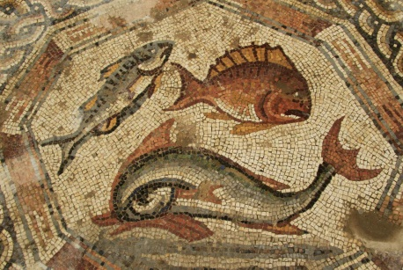
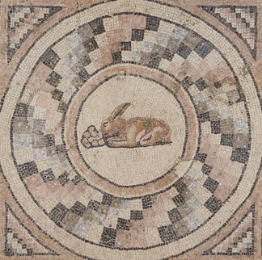
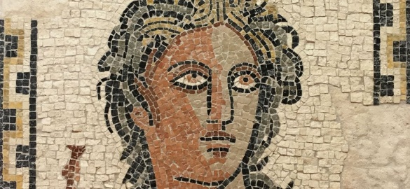

Forever Facts  Roman Mosaics decorated floors or Roman villas or other buildings.  How large and impressive a mosaic was, told people about how rich or powerful the owner was.  The tiny stones or tiles were called ‘tesserae’ and these were stuck to the floor with mortar.  It took many thousands of tiny pieces to make a mosaic.  The pictures were sometimes of scene from life in Roman times and sometimes pictures of Gods.  Skills  I can generate a repeating mosaic style pattern using coloured squares.  I can print a neat boarder design with good technique.  I can evaluate and analyse my work and that of others.  I can design and finish printing a large scale mosaic style picture.  I can evaluate my finished work. | Exciting Books | Subject Specific Vocabulary  Mosaics A pattern or image made of small regular or irregular pieces of coloured stone, glass or ceramic  Tesserae The tiny stones used to make mosaics.  Print Make a mark by pressing something on a surface.  Boarder The edges of a mosaic.  Mortar A type of cement that held the tiny stones in place.  SMSC: Spiritual – consider the world around them starting at school. Social – working cooperatively, having opportunities to give and receive peer feedback. Cultural – gain an appreciation of different art.
Our Endpoint

To create a Roman Mosaic.

