History FLE Y3/4 Stone Age to the Iron Age
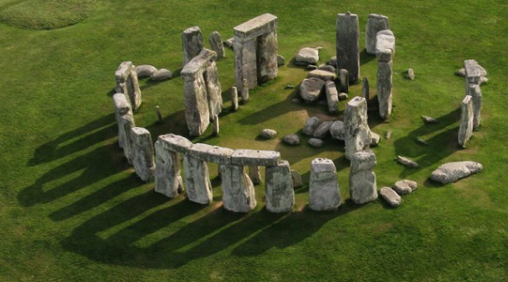
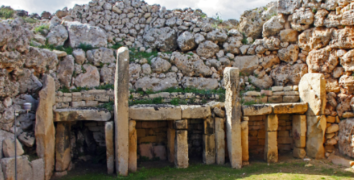
What I have learnt before:
There are similarities and differences between ways of life in different periods.

Forever Facts  Regularly address and sometimes devise historically valid questions about change, cause, similarity and difference, and significance.  Continue to develop a chronologically secure knowledge and understanding of British, local and world history, establishing clear narratives within and across the periods they study.  Understand how our knowledge of the past is constructed from a range of sources and that different versions of past events may exist, giving some reasons for this.  Skills  Construct informed responses that involve thoughtful selection and organisation of relevant historical information.  Note connections, contrasts and trends over time and  develop the appropriate use of historical terms.  To show our understanding of the BC/AD chronology and show the sequence of events in prehistory.  Culture Capital: allows students to make connections between people and events in different places around the world. | Exciting Books  Our Endpoint | Subject Specific Vocabulary  bronze A metal alloy made from a mixture of copper and tin. It is a much harder and more long-lasting material than stone or copper alone.  alloy A metal made by combining two or more metals to improve its properties.  bone marrow The substance inside bones, which is high in fat and a good energy source.  earthwork A large bank or mound of soil that has been made on purpose.  Celt A modern term for the people living in Europe during the Iron Age. The ‘Celts’ were made up of many different tribes. The word ‘Celt’ comes from a Greek word.  sacrifice To give something up, break it or kill it as an offering to a god or gods.  tribe A group of people, often related through family, culture and language, usually with one leader.  iron A metal that is stronger and harder than bronze.

