Computing FLE Y3/4 Internet Safety
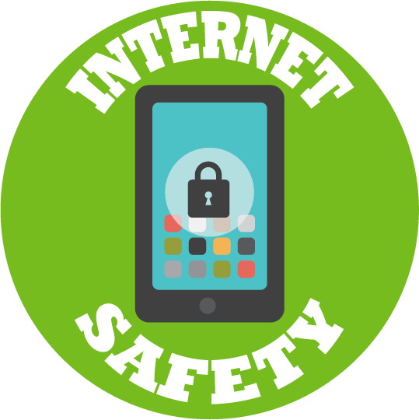
What I have learnt before:
How to select and use Safe Search filters when we use the internet.

How to stay SMART online.

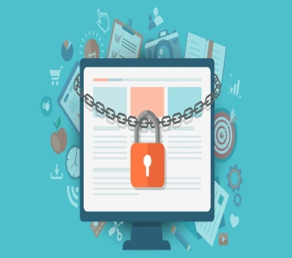
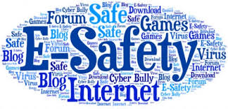
Safe
Meet
Accept
Reliable
Tell

Forever Facts  Understand computer networks including the internet; how they can provide multiple services, such as the World Wide Web, and the opportunities they offer for communication and collaboration  Skills  Use search technologies effectively, appreciate how results are selected and ranked, and be discerning in evaluating digital content.  Select, use and combine a variety of software (including internet services) on a range of digital devices to design and create a range of programs, systems and content that accomplish given goals, including collecting, analysing, evaluating and presenting data and information.  Use technology safely, respectfully and responsibly; recognise acceptable/unacceptable behaviour; identify a range of ways to report concerns about content and contact. | Exciting Books  Our Endpoint  To show our understanding by presenting information about Internet Safety. | Subject Specific Vocabulary  Cyberbullying The bullying of another person using the internet, mobile phones and other digital devices, with the intent to deliberately upset them.  Email Messages sent by electronic means from one device to one or more people.  Password A secret word, phrase or combination of letters, numbers and symbols that must be used to gain admission to a site or application such as a website.  Online Communities a group of people with common interests who use the internet to communicate (email, web sites, instant messaging).  Online Safety Refers to staying safe when having a presence online.  Secure Keeping personal information online safe.  Social Media network An online platform that allows users to create a public profile and interact with other users on the website.  Culture Capital: Having a good understanding of how the internet work and what behaviours are appropriate online is vital throughout life.

