History FLE Y3/4 The Indus Valley
Skills
Understand that events from the past are represented and interpreted in different ways, and that sources can confirm or contradict
I can use dates and terms accurately, using key dates when describing events.
I can use the internet for research.
I can choose and discriminate between a range of information, and use this to ask questions.
I can guess what objects from the past were used for, using evidence to support my answers.
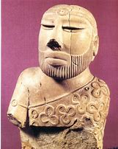
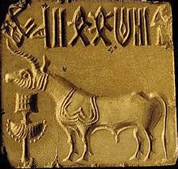
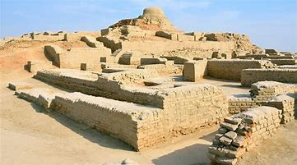
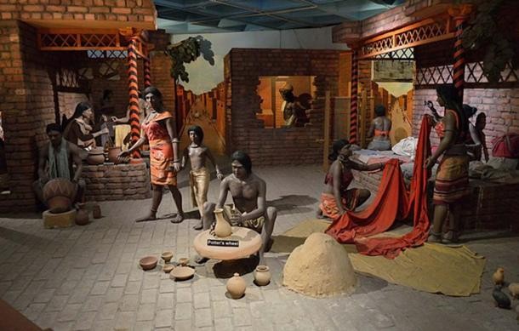
Forever Facts  Men wore tunics or a simple loincloth. Women wore long dresses but sometimes just skirts.  The Indus people were among the first to make jewellery, which was worn by both men and women.  It is thought that the most important buildings were located in a city’s citadel and that the rulers of the city lived there.  Although lots of farmers, fishermen and traders lived in small villages, it is thought that up to 80,000 people lived in Mohenjo-Daro and Harappa, the biggest of many cities.  Water was very important and cities had complex drainage systems. Reservoirs were built for storing water.  The Ghaggar-Hakra river now only flows during the monsoon rain season. It is thought that it dried up around 2000 BC and that this led to the decline of the Indus civilisation.  Thousands of soapstone seals were found across the Indus Valley. People may have used them to stamp on clay to label their goods. They showed animals, symbols, people and gods  3300BC Farmers start small settlements in the Indus Valley, in what is now south-east Afghanistan, Pakistan and north-west India.  1500BC The Indus civilisation comes to an end  SMSC: Spiritual – exploring artefacts in order to give children a sense of the past and aid them in understanding the people who used these objects. Moral - notions of right and wrong are explored in connection with how early civilisations used to live. Social – working collaboratively to examine how other civilisations have had an impact on the development of ‘British’ culture. Cultural – understand and empathise with how early civilisations used to live.  · | Exciting Books  Our Endpoint  To describe some key features of this early civilization. | Subject Specific Vocabulary  Soapstone A soft rock that can be carved easily  Seal A small stamp with an individual design, used for pressing into a soft material like clay to show who made or sent an item. ‘Seal’ can also refer to the stamped clay  Citadel An area on a mound of land, higher than the rest of a city. Sometimes citadels have walls to separate them from the rest of the city  Loincloth A piece of cloth wrapped around the hips, similar to a skirt but generally worn by men.  Charles Mason Charles Masson had been in the British army in India. Other people who contributed to the discovery and excavations of Harappa and Mohenjo Daro include Sir John Marshall, Rai Bahadur Daya Ram Sahni, RD Banerji and Sir Alexander Cunningham.  Bitumen tar A semi-solid, sticky, black substance.  Goods Items for sale or things that have been bought.

