PE FLE Y3/4 Gymnastics
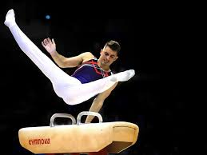
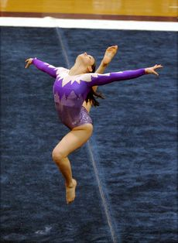
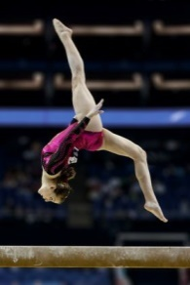

Forever Facts  The Ancient Greeks prepared their young men for war by doing gymnastics!  Women weren't permitted to compete in gymnastic events until the 1920s  Gymnastics is a sport which involves doing exercises which need strength, flexibility, balance and control.  In women's gymnastics, there are four activities: floor, uneven bars, balance beam, and vault. In men's gymnastics, there are six activities: floor exercise, parallel bars, high bar, pommel horse, vault, and rings.  Skills  I can make good use of creativity and imagination  I can convey expression and emotion in gymnastics  I can create a gymnastic sequence | Exciting Books | Subject Specific Vocabulary  Control To perform a movement with strength and determination  Floor A range of movements carried out at ground level  Vault A leap performed over a form used to represent a horse  Stag jumps An elegant jump using pointed toes and good height  Sequence A range of movements linked together  Movement The act of moving your body in a way to fit the purpose  SMSC : Spiritual - Explore, creativity through producing Gymnastic routines. Cultural - Gaining an understanding of different sports and their foundations. Moral - following instructions and completing moves safely.
Our Endpoint

To be able choreograph a sequence of movements and preform to the class

