Geography FLE Y3/4 UK
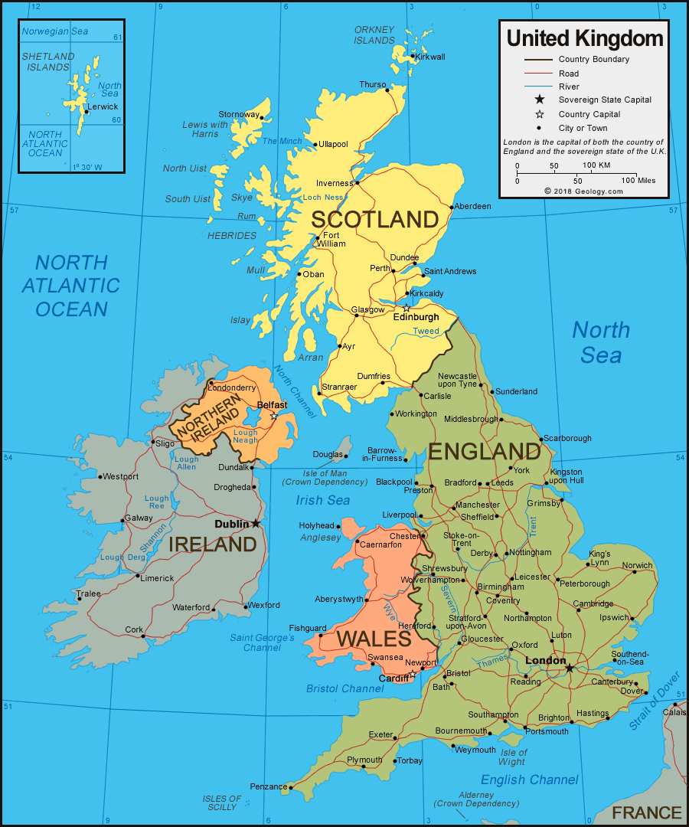
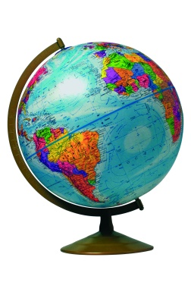

Forever Facts  Understand and use the concept of reciprocal link between physical ad human features.  Understand the different uses of different places.  To work out a location using a range of information.  Skills  To use maps / atlases to show physical and human features.  To use contents and index pages of an atlas.  To use compass points to build on knowledge of the UK and the wider world. | Exciting Books  Our Endpoint  SMSC: Spiritual – he study of real people in real places means that it constantly links and develops students spiritually. Moral - he study of real people in real places means that it constantly links and develops students spiritually. Social – collaborating as a group and this collaborative learning continues throughout. Cultural – looks at various cultures and their influences across the world as well as more local studies and their cultural awareness is developed as a result.  ·  To name and locate countries and cities in the UK. | Subject Specific Vocabulary  county A small area of the UK containing lots of towns and villages.  prime meridian An imaginary line which divides the earth into eastern and western hemispheres.  immigration People moving to another country to live there permanently.  UK The United Kingdom of Great Britain and Northern Ireland.  Great Britain England, Scotland and Wales.  landmark A feature of the landscape or area that is easily recognised.  millennium A time period of 1000 years. The New Millennium started 1st January 2000.

