History FLE Y3/4 The Roman Empire
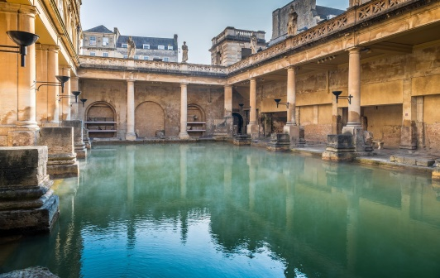
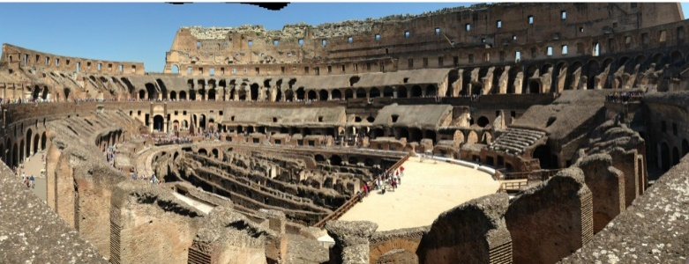
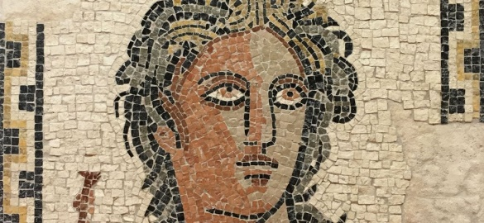

Forever Facts  Latin, the official Roman language, forms the roots of many of our words.  The romans built elaborately designed baths where people would go to relax. Public baths, amphitheatres, temples can all be seen around Britain.  We use Roman names for months (January, July) and planets (Mars, Jupiter).  The Romans were famous for building long, straight roads to transport legions, trade goods and messages from the Emperor. You can still see some Roman roads today, 2000 years after they were built.  Early in Roman times people believed in many different Gods and Goddesses whom they believed controlled different aspects of their lives, such as time, love and the seas.  Skills  I can place events from the Roman Empire period on a timeline.  I can correctly use terms related to the Roman Empire Period.  I can find out about the everyday lives of the Romans.  I can identify key features and events during the Roman period.  I can offer a reasonable explanation for some events during the Roman times.  I can look for links and effects in the Roman times.  I can ask questions and use research to help answer these (links to Computing) | Exciting Books  Our Endpoint  SMSC: Spiritual – exploring artefacts in order to give children a sense of the past and aid them in understanding the people who used these objects. Moral - notions of right and wrong are explored in connection with how the Romans used to live. Social – working collaboratively to examine how the Romans had an impact on the development of ‘British’ culture. Cultural – understand and empathise with how the Roman’s used to live.  ·  To describe some key features of the Roman Empire. | Subject Specific Vocabulary  Invasion One country attacking another to take it over  Legion One unit of the Roman army; had 4,000 to 6,000 soldiers in. Lead by a centurion.  Emperor The leader of an empire. Similar to a king or queen.  Amphitheatre Where the Romans would go to be entertained.  Temple A place of worship. A house of a Roman god or goddess.  Mosaic (links to Art) One picture made up of thousands of small tiles (tessellates)  Senate The Roman government.

