Science FLE Y3/4 Rocks
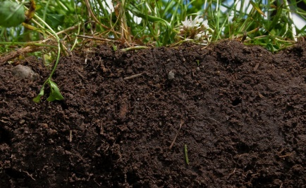
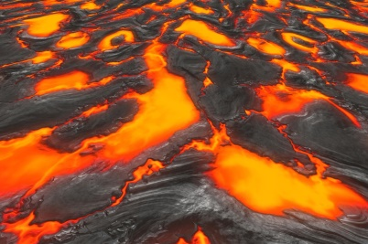
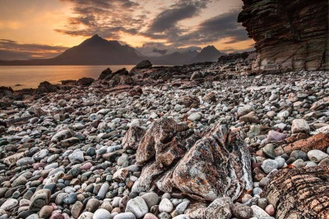

Forever Facts  There are 3 types of naturally occurring rock (igneous, sedimentary, metamorphic).  There are different types of human rocks and Human-made rocks.  Soil is the uppermost layer of the Earth. It is a mixture of different things: minerals; air; water; organic matter.  To know that questions can be answered in different ways.  To ask relevant questions.  Skills  I can classify simple features.  I can record findings using scientific language.  I can make and record observation.  I can make careful observations and comparisons.  I can ask relevant questions,  To present findings to an investigation about different types of soil. | Exciting Books  Our Endpoint | Subject Specific Vocabulary  igneous rock Rocks that has been formed from magma of lava.  sedimentary rock Rock that has been formed by layers of sediment being pressed down hard and sticking together. You can see layers of sediment in the rock.  metamorphic rock Rock that started out as an igneous or sedimentary rock but changed due to being exposed to extreme heat or pressure.  magma Molten rock that remains underground.  sediment Natural solid material that is moved and dropped off in a new place by water or wind, e.g. sand.  permeable Allows liquids to pass through it.  impermeable Does not allow liquids to pass through it.  SMSC: Spiritual – make sense of and reflect on our natural world. Moral – moral decisions are an important aspect of how we can have a positive effect on our environment. Social – working collaboratively, sharing ideas, data, and results. Cultural – we explore how scientific discoveries have shaped the modern world.  ·

