PE FLE Y1/2 Being Healthy
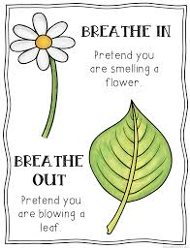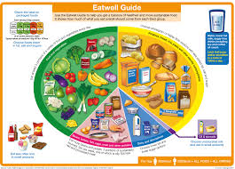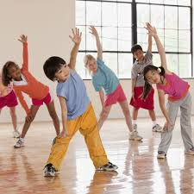
Knowledge  Keeping healthy means caring for your body so you have enough energy to learn, play and grow. FF  Regular sport and exercise help us to stay healthy. FF  Before we begin any sport or exercise, we need to warm up to prepare our bodies and to avoid hurting our muscles. FF  At the end of any exercise or sport, we need to cool down to help our bodies recover. FF  Everyone should have their ‘5 a day’ – this means five portions of fruit and vegetables, to get the right amount of nutrients. FF  All foods contain nutrients which your body needs to stay active throughout the day. Some foods have more nutrients than others. FF  It's important not to eat too much sugar and salt: sugary foods are bad for your teeth and salty foods can lead to heart disease. FF  Being active means physical activity like sport and mental activity like completing wordsearches.  Mindfulness helps us to be calm and quiet which is good for our well-being. | Exciting Books | Subject Specific Vocabulary  healthy keeping healthy means doing things that are good for your body – things like eating nutritious foods, exercising, brushing your teeth and getting enough sleep  exercise to be physically active  active to move  control to be in charge of your body movements  coordination the ability to use different body parts together smoothly  agility to change the direction of your body movement quickly and easily  flexibility to have the full range of movement in your body  Skills  Explore, copy and repeat simple skills and actions  Understand the importance of being active.  Talk about how to exercise safely.  Begin to move with increasing control and care  Make simple moves with increasing control and coordination
Our Endpoint
To complete a workout applying all three key skills of agility, control and coordination.

