RE FLE Y1/2 The Bible
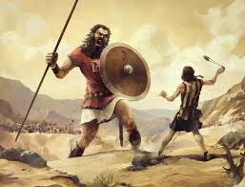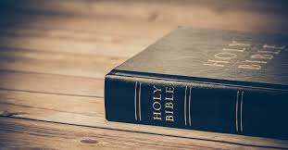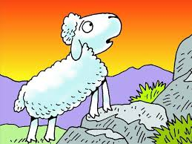
Knowledge  There is a special book to Christians which is called ‘The Bible’. FF  The Bible contains the ‘big story’ of God.  Christians believe that God made the world in the beginning.  Christians believe that God rescued people when they got things wrong.  Christians believe that God’s message was brought to people by Jesus.  Christians believe that God’s message is carried on by the Church.  There are different types of writing in the Bible which include: stories, letters, poems and laws. FF  ‘David and Goliath’ and ‘Noah and the ark’ are both stories included in the Old Testament.  ‘The Lost Sheep’, ‘The Good Samaritan’ and ‘Jesus calms the storm’ are a few of the stories included in the New Testament.  Christians use the Bible to help them learn about how to live their lives. | Exciting Books | Subject Specific Vocabulary  Bible a special and important book containing stories and other writings  message a way of telling someone something either written down, said or signalled  Old Testament a collection of books which tell the stories before Jesus was born  New Testament a collection of books which tell the stories after Jesus was born  samaritan a person who helps someone when they are hurt, scared or upset  moral a lesson about what is right and wrong learned from a story or an event  belief to have trust or confidence in something or someone  Skills  Ask relevant questions  Listen carefully to, respond to and retell a story  Consider similarities and differences  Reflect on things that are important to us
Our Endpoint
A creative representation of our chosen Bible story,

