PE FLE Y3/4 Football
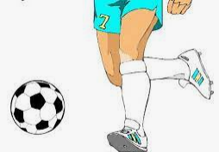
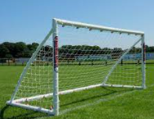
What I have learnt before:
Regular sport and exercise help us to stay healthy.

The aim of the game is to score goals past the opposition’s goalkeeper.

Skills  Dribble with small touches into space.  Send a football to someone on the team, using different parts of foot.  Keep a ball under control when receiving a range of passes from team.  Mark another player and begin to attempt interceptions.  Forever Facts  Understand where the space is and can move into it.  Understand what effects exercise has on our bodies.  Understand the importance of warming up and cooling down.  Understand how performances can be improved through practise and reflection. | Exciting Books  Our Endpoint  To demonstrate an understanding of the key skills learned in Football. | Subject Specific Vocabulary  Dribbling Moving with the ball and maintaining possession of the ball.  Passing Made with the arm moving above the shoulder.  Shooting – strike the ball towards the goal.  Control – cushion the ball when it is moving towards you.  Handball No outfield player can touch the ball deliberately with their hand.  Strike Hit the ball hard at the goal.  Positions goalkeeper, defender, midfielder, winger, attacker.  Culture capital: Team work – Work with players in team, positive team player  ·

