RE FLE Y3/4 How and why do people try to make the world a better place?
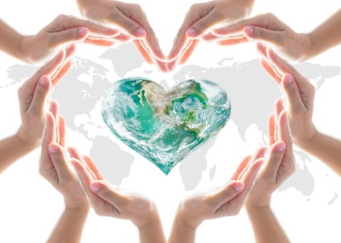
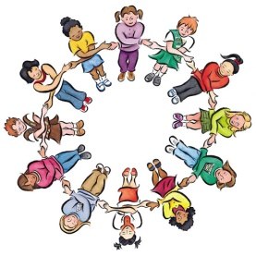

Forever Facts  Recognise the things that motivate me to care for others in the world and the things that motivate others, including religious believers and non-religious believers.  Understand how different people interpret the needs of the world in different ways.  Understand my own views of what the world needs and suggest ways in which these problem might be solved by religious or non-religious believers.  Skills  Raise questions and suggest answers about why the world  is not always a good place, and what are the best ways of  making it better.  Make links between some commands for living from religious  traditions, non-religious worldviews and pupils’ own ideas.  Express their own ideas about the best ways to make the world  a better place, making links with religious ideas studied, giving  good reasons for their views.  To discuss and reflect on the question: How and why do people try to make the world a better place?  SMSC: Spiritual – reflect on self-awareness and their own beliefs. Moral - learning about our responsibility for others and thinking about concepts of right and wrong. Social – many opportunities to work collaboratively. Cultural - value diversity as they learn about different beliefs. | Exciting Books | Subject Specific Vocabulary  sin A bad action. To go against rules given by God.  confess To admit you have done something wrong.  repent To feel sorry (and express how sorry you are) for something you have done wrong  ten Commandments The ten most important laws, revealed by God, teaching people how to live their lives.  law the system of rules which a particular country or community recognises as regulating the actions of its members and which it may enforce by the imposition of penalties.  tikkun olam The Hebrew phrase tikkun olam (pronounced tee-KOON oh-LUHM) means "world repair."  tzedaka a Hebrew word meaning “righteousness" but commonly used to signify charity.  zakah Zakah is the practice where a Muslim gives 2.5 per cent of their wealth over a certain amount to charity, after they have paid for what is necessary to support themselves and their families.
 | Our Endpoint

